Franklin Zheng
Ms. O’Neal
10/29/19
Computer Science IV/V

Functional Overview:
OneWay is a website intended for people to plan and organize carpools. Users will be able to plot out routes from designated start and endpoints, add waypoints along the way, and save commonly used routes. Primarily targeted towards those who drive themselves or others often, OneWay aims to create a more friendly and intuitive way to plan out trips.

Design Overview:
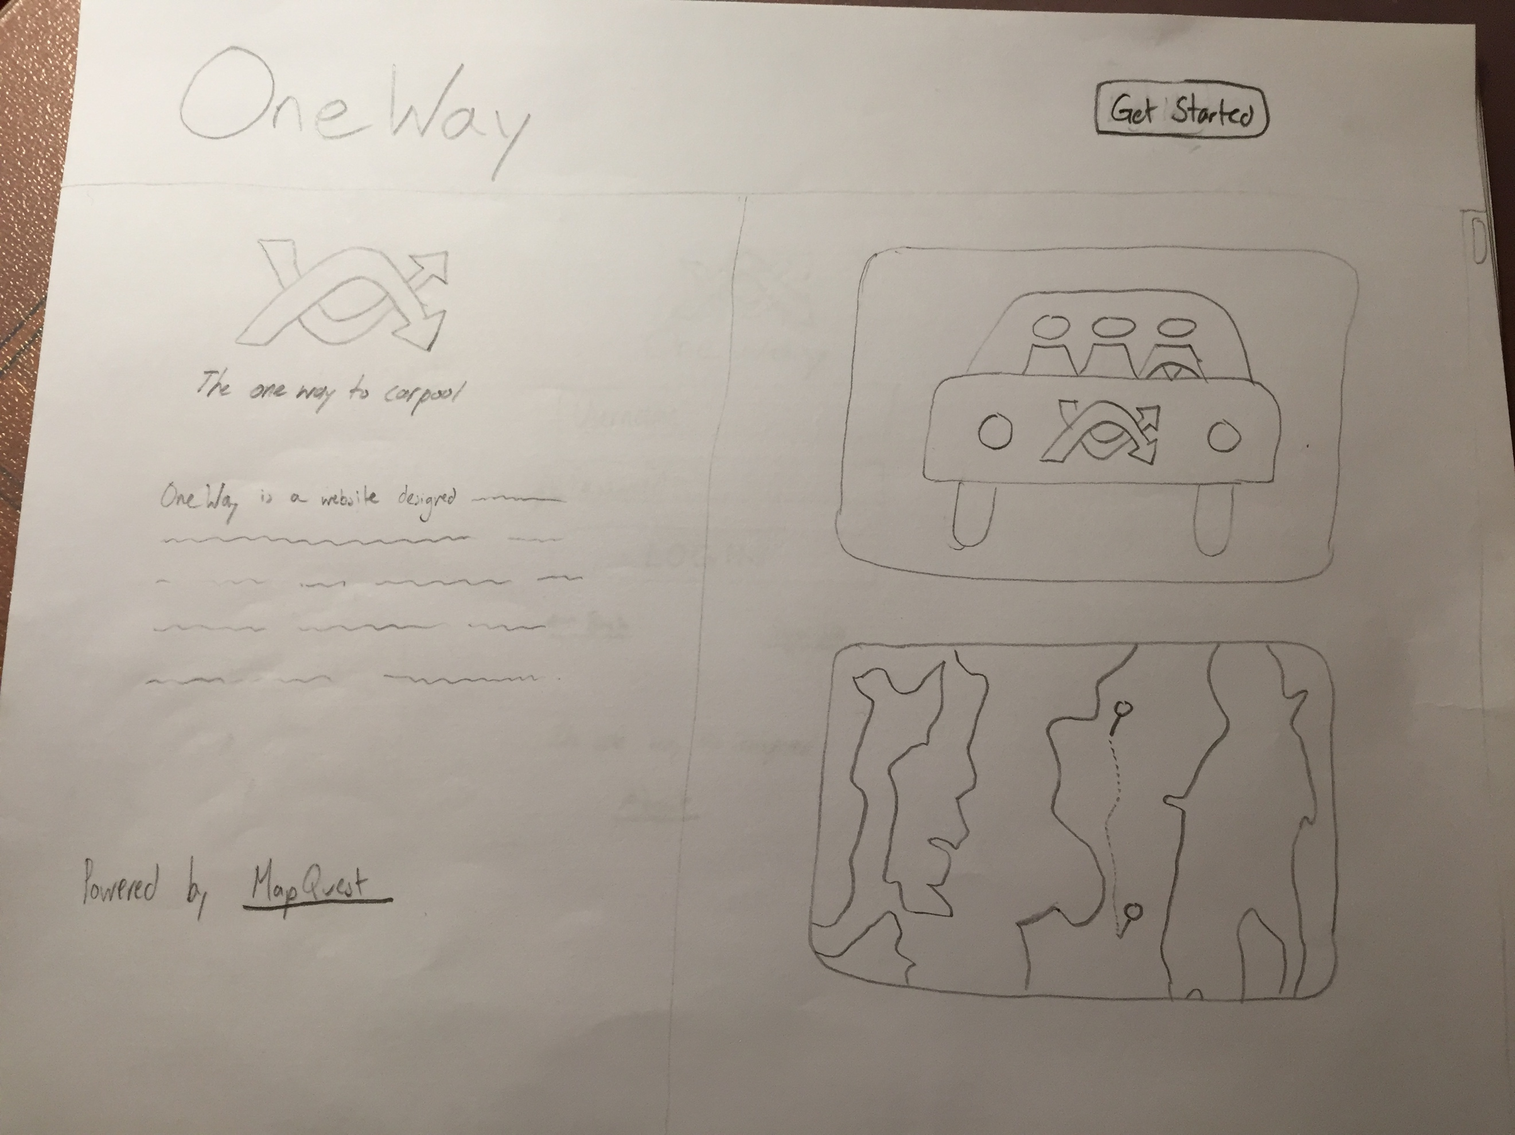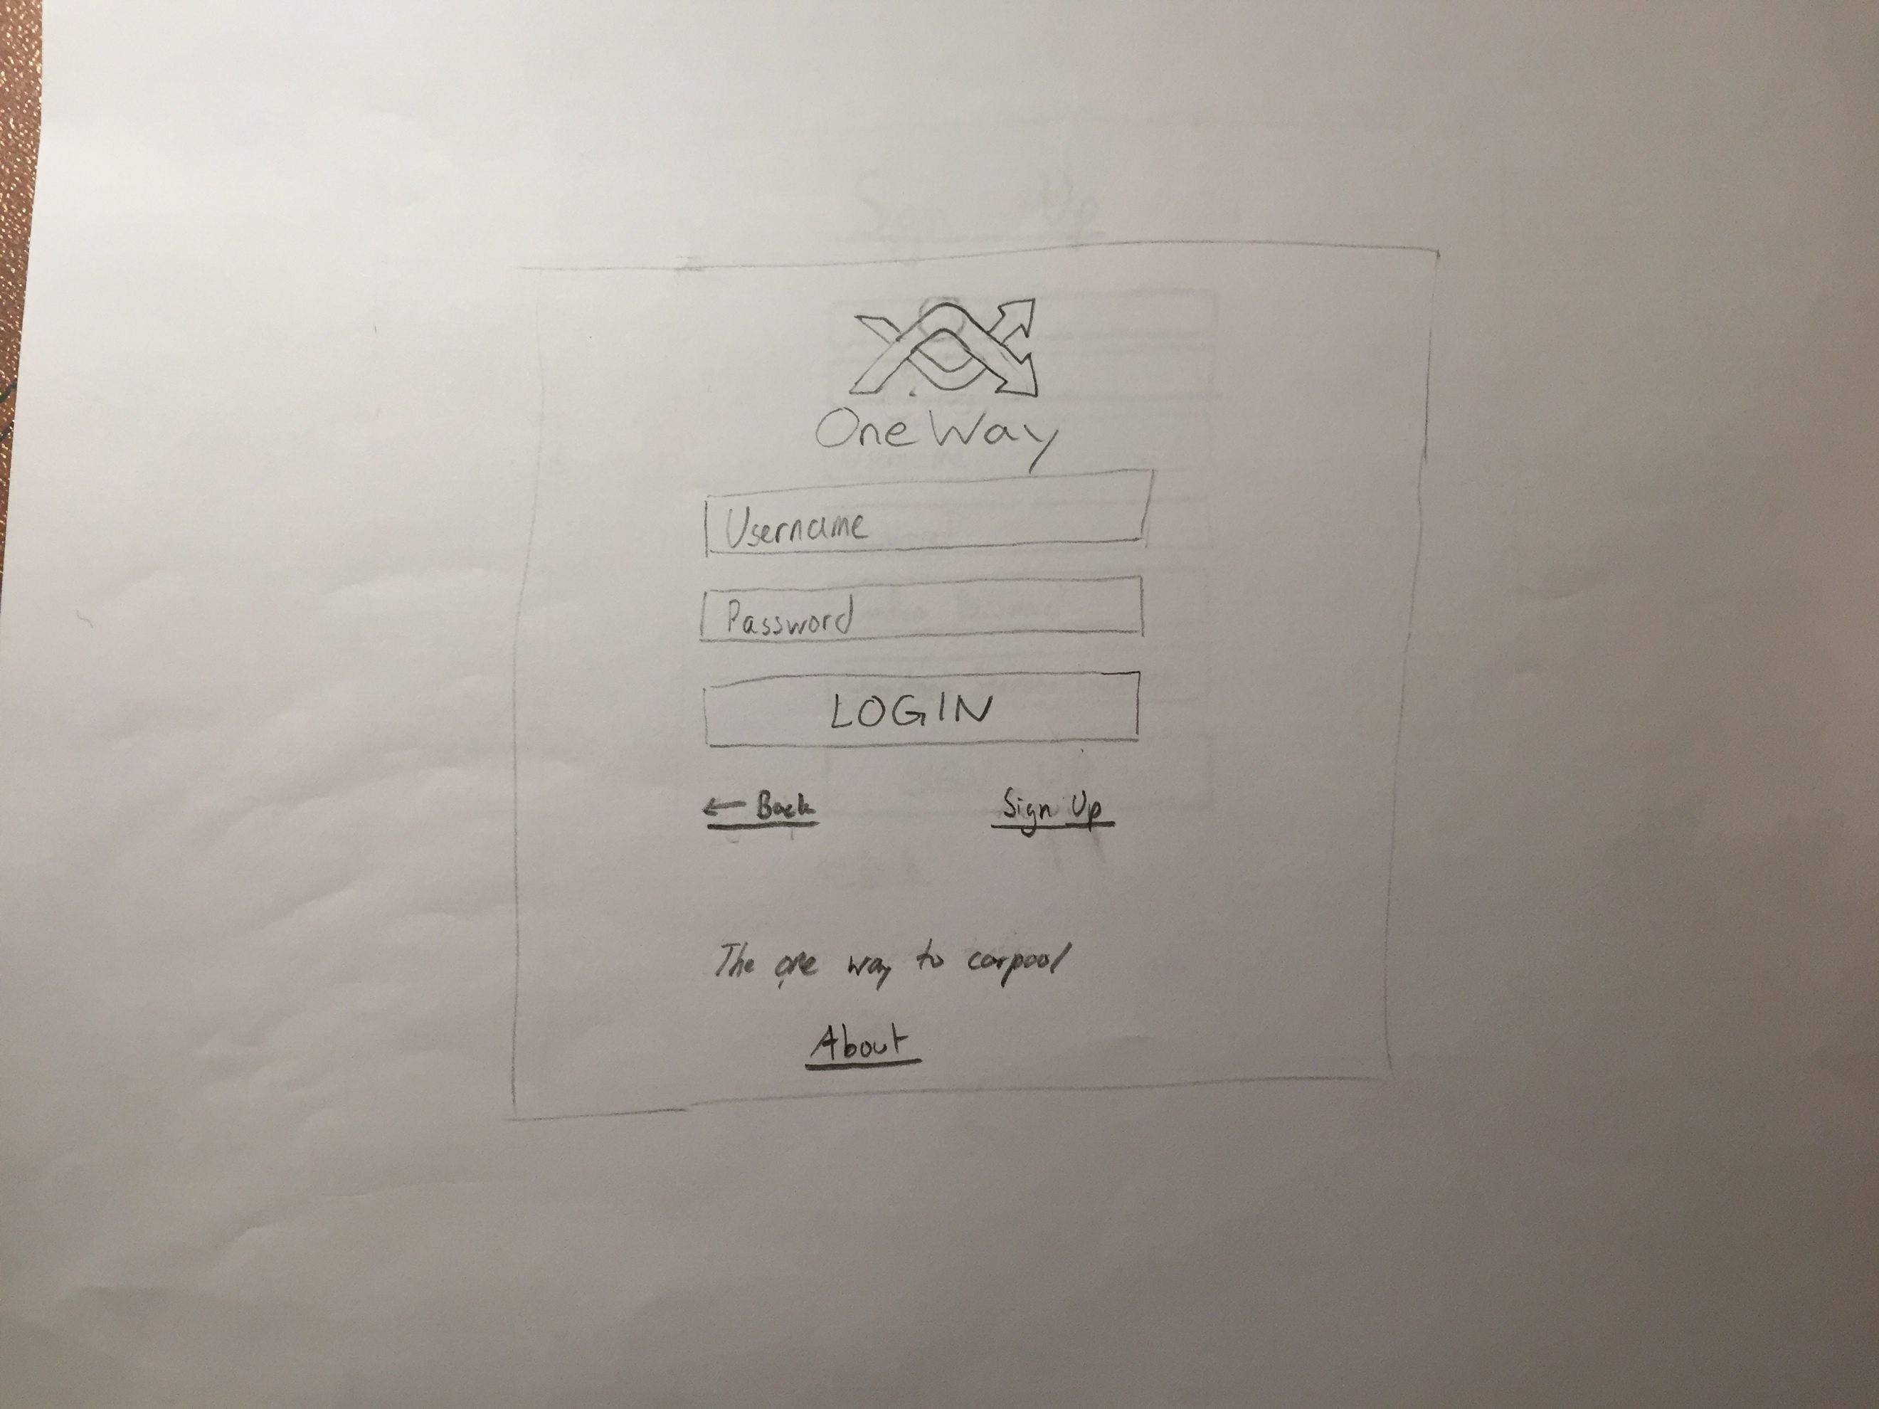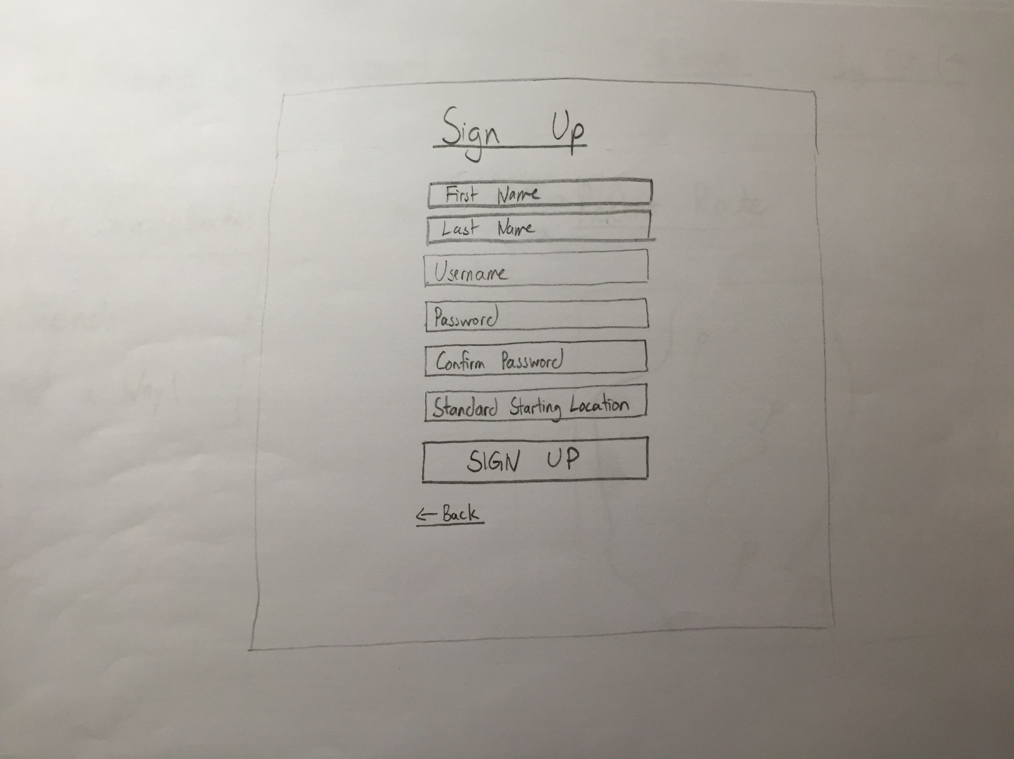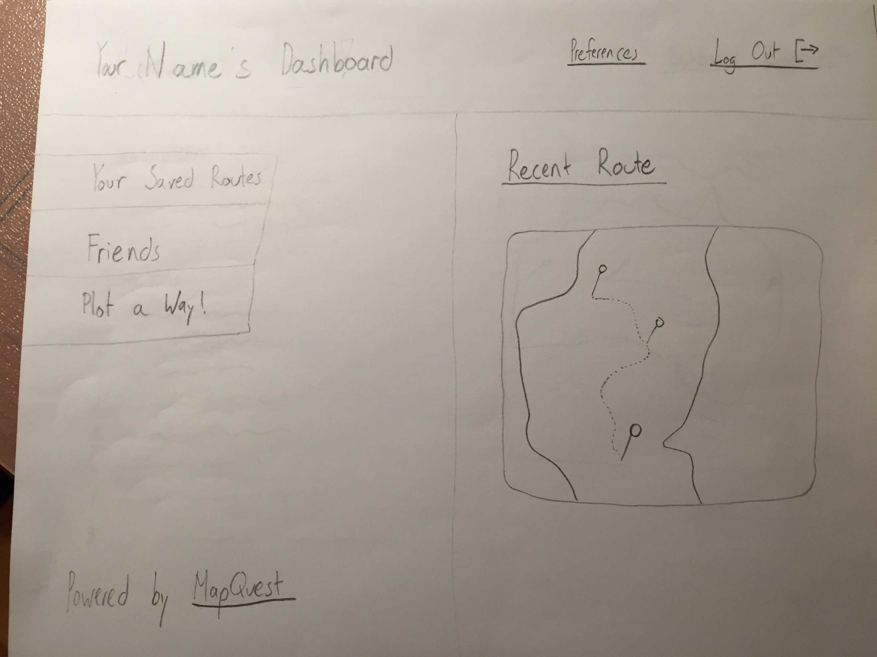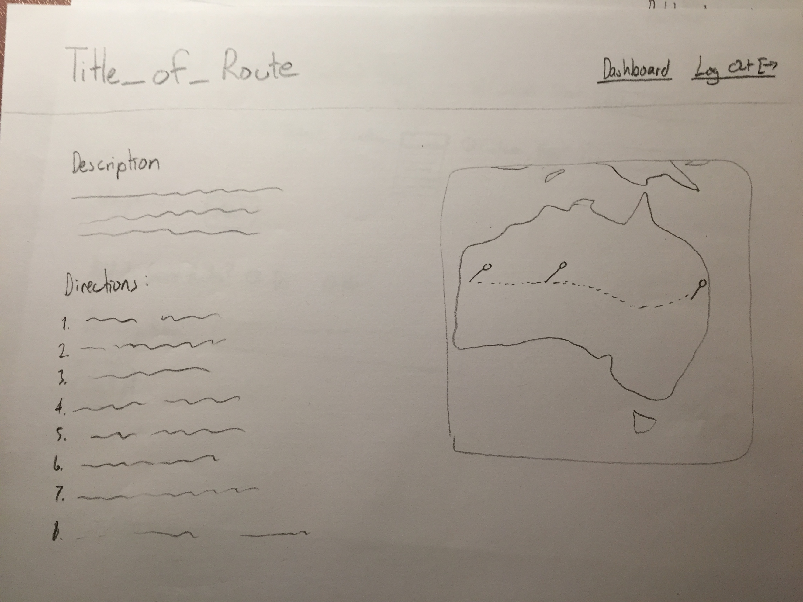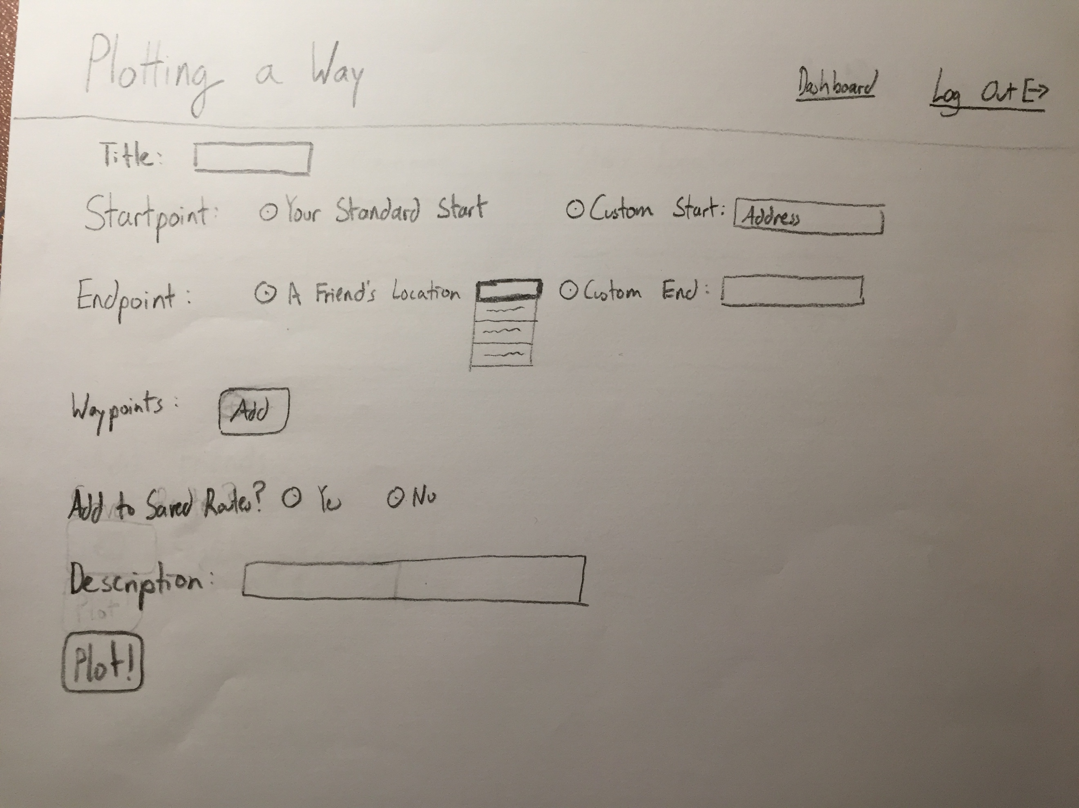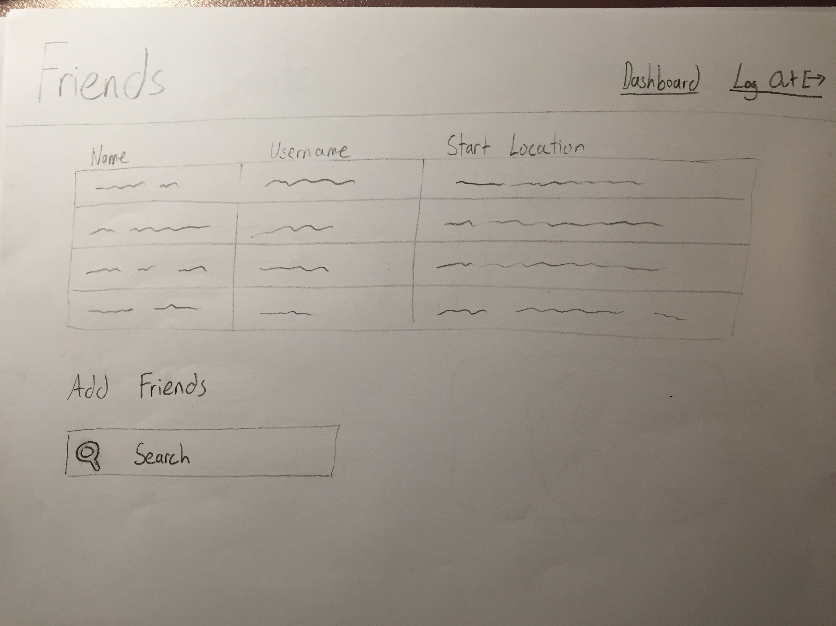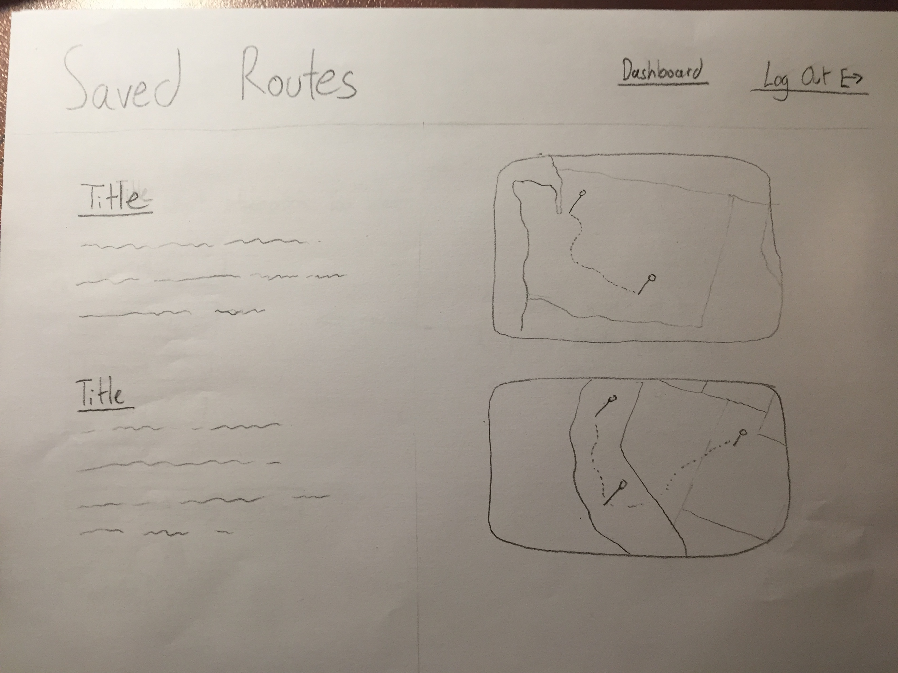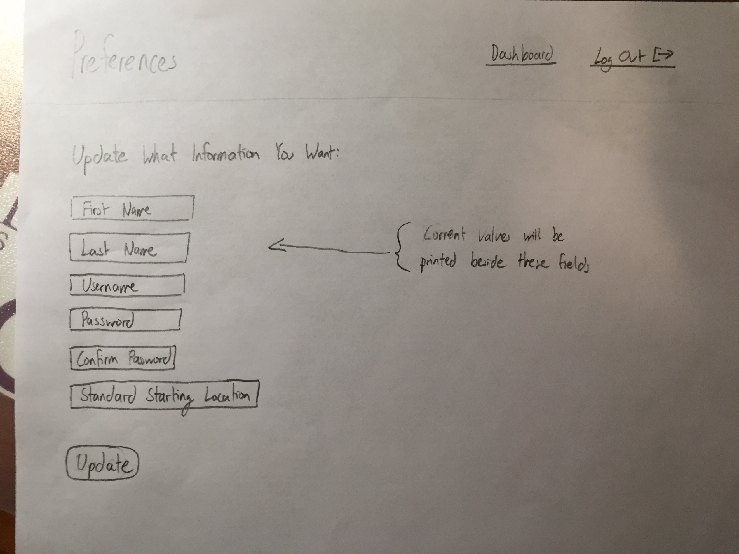

Design Testing Results:
Thomas Yim and Rowan Sharp both individually tested my low-fidelity prototype. The feedback I was given consisted of providing a link to the MapQuest site, showing current values next to the information update section in Preferences, rewording “Save Route?” to “Add to Saved Routes?”, and potentially adding an address verification system.

Prioritization of Features:
Definitely will implement:
- Sign up/login
- Plotting of a route
- Saving of routes
- Adding of friends
- Updating of personal information
- Displaying of a route’s details

Will Implement if I have time:
- Address verification system
- Viewing maps that have the user tagged on as a waypoint

Database Design:
I expect to have a table dedicated to user IDs, usernames, passwords, full names, and their addresses. I will have a related table linked via the users’ IDs which will contain saved routes and their titles and descriptions. I will also create a related table that contains every user’s friends in order to provide a “friends” functionality to simplify creating waypoints.

Proposed Implementation Schedule:

11/7 Signup/login and personal information update functionalities completed

11/14 Route plotting and saving functionality implemented

11/21 Friends functionality and route detail display implemented

11/27 All parts complete. Minor CSS changes.

12/6 Fully complete

Potential Showstoppers and Open Questions:
The major showstopper that is evident at the moment is my inability to incorporate the MapQuest API into my website. I am unsure about how to actually provide MapQuest with inputs (startpoint, endpoints, waypoints) or how to save routes that have been plotted out. I also am unsure of how to check that inputted addresses actually exist. This needs to be addressed in order to have input verification.

