Name: Liz Song
Project Name: Lakeside Sign-in Website
Date: October 28th, 2019
Web Project Design Document
Functional Overview
My project will be a website that Lakesiders can use to sign in and out during school hours without having to walk to the WCC to manually sign in/out. This is for the students who leave campus and think about signing-in/out but then decide not to because the WCC is not close to any parking lots and it’s inconvenient and daunting to have to walk across campus to accomplish such a “trivial” task. Perhaps by giving students and easier way to access this sign-in/out sheet, it will motivate them to actually do it so the school can keep better track of where students are at all times.
I think students at Lakeside would use this website.

Design Overview
Ideally, if the website was actually to be implemented at Lakeside, it would already have access to all Lakeside students’ schedules. However, for the purpose of the project, students input their own schedule (or, more precisely they enter when their free periods are), which then gets entered into the database.
First, if the student is returning, there’s a “login” page where they enter their credentials. If the student is new, they have a “create account” feature they can click on, where they will be prompted to enter their first and last name, their graduation year, and a password to create an account similar to how Lakeside formats their account names.
Once they log in, if they are a first-time user, they will be prompted to click (using a check-box form) on which frees they have. The database stores this information, and they are redirected to the main page. From there, if it’s the morning it auto directs to a website that has “SIGN IN” on a big button. Once they click it, they are signed in for the day and that status gets saved to the database. Next time they refresh the page, they will be shown a webpage that says, “Current status: signed in” and there’s a big button with “SIGN OUT” on it. If they click that, they will be asked why they’re leaving and a warning shown if they are missing any class. If they confirm, they will now be signed out. Next time they open the page, there will be a big button that says, “Current status: signed out” and a big button with “SIGN IN” on it. If they try to sign in when they have class, a notification will pop up saying they’re late to a class. Once the day ends, they are automatically signed out.
Design Testing Results
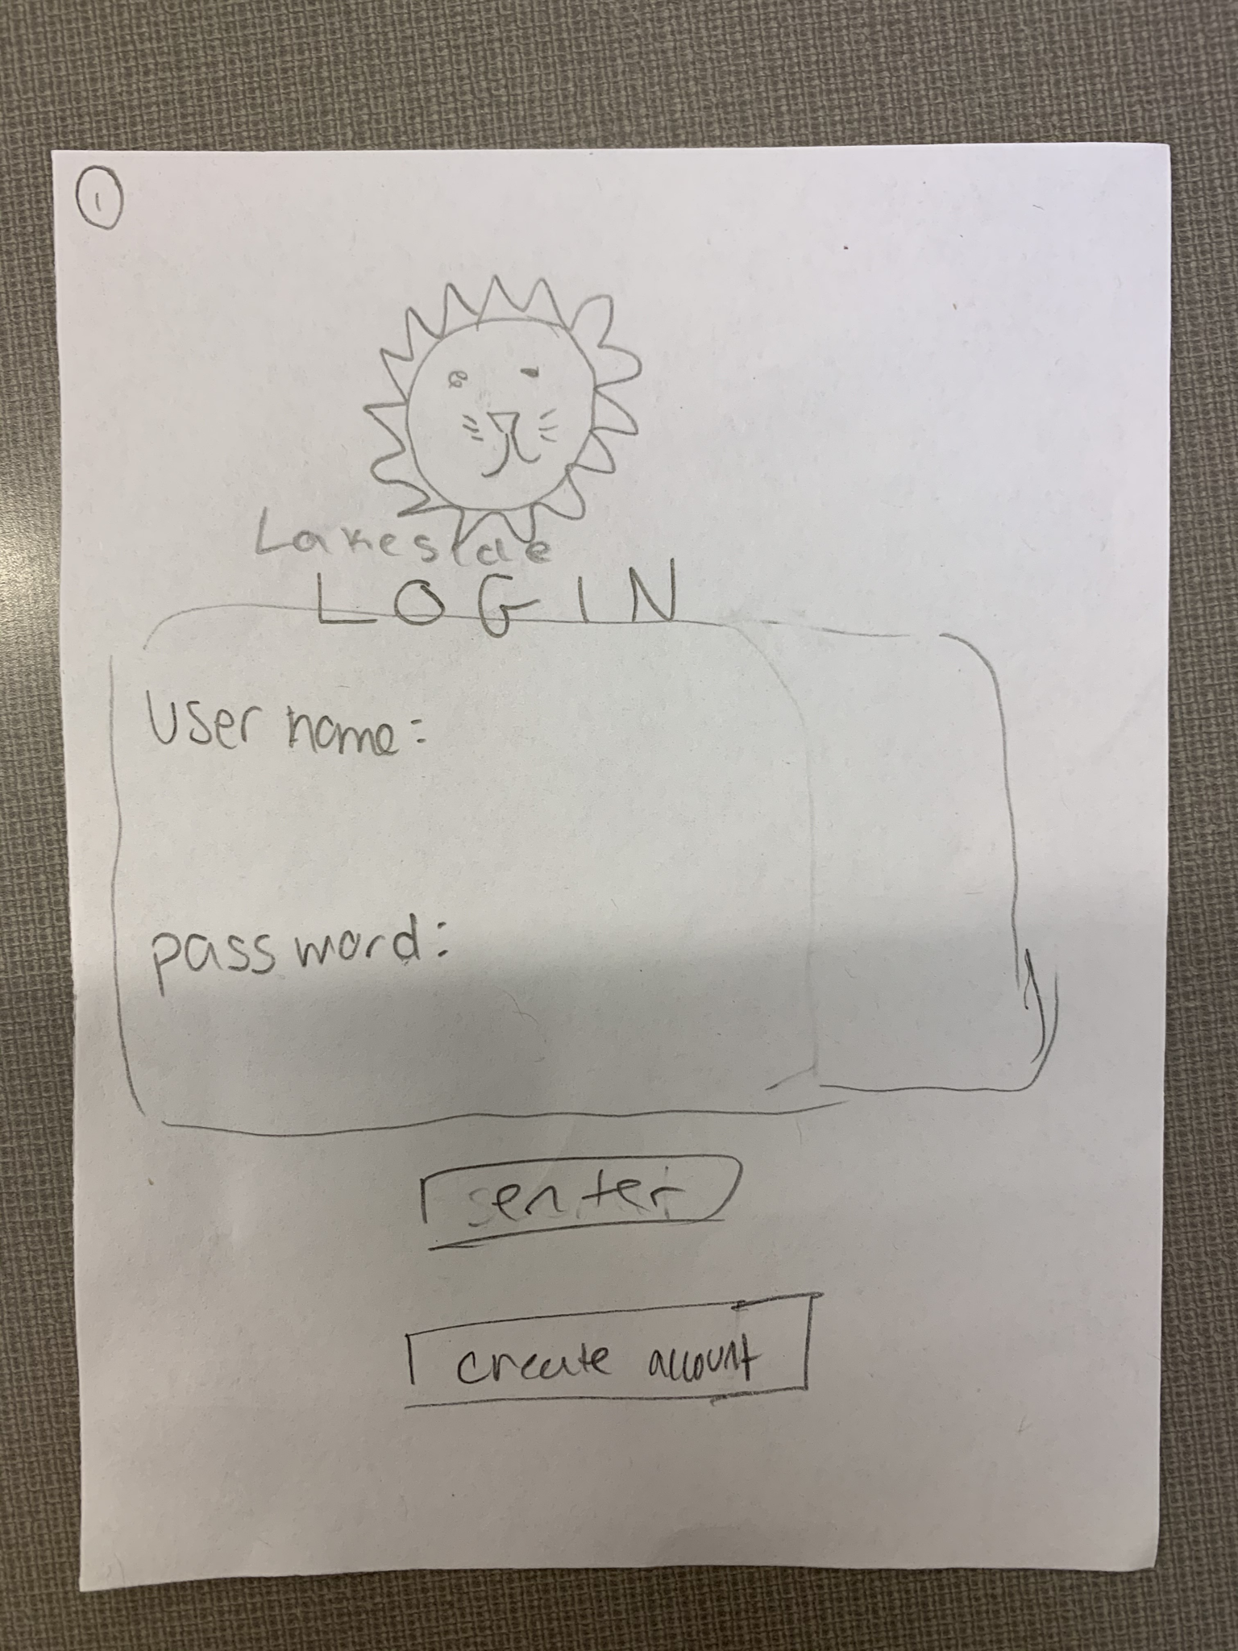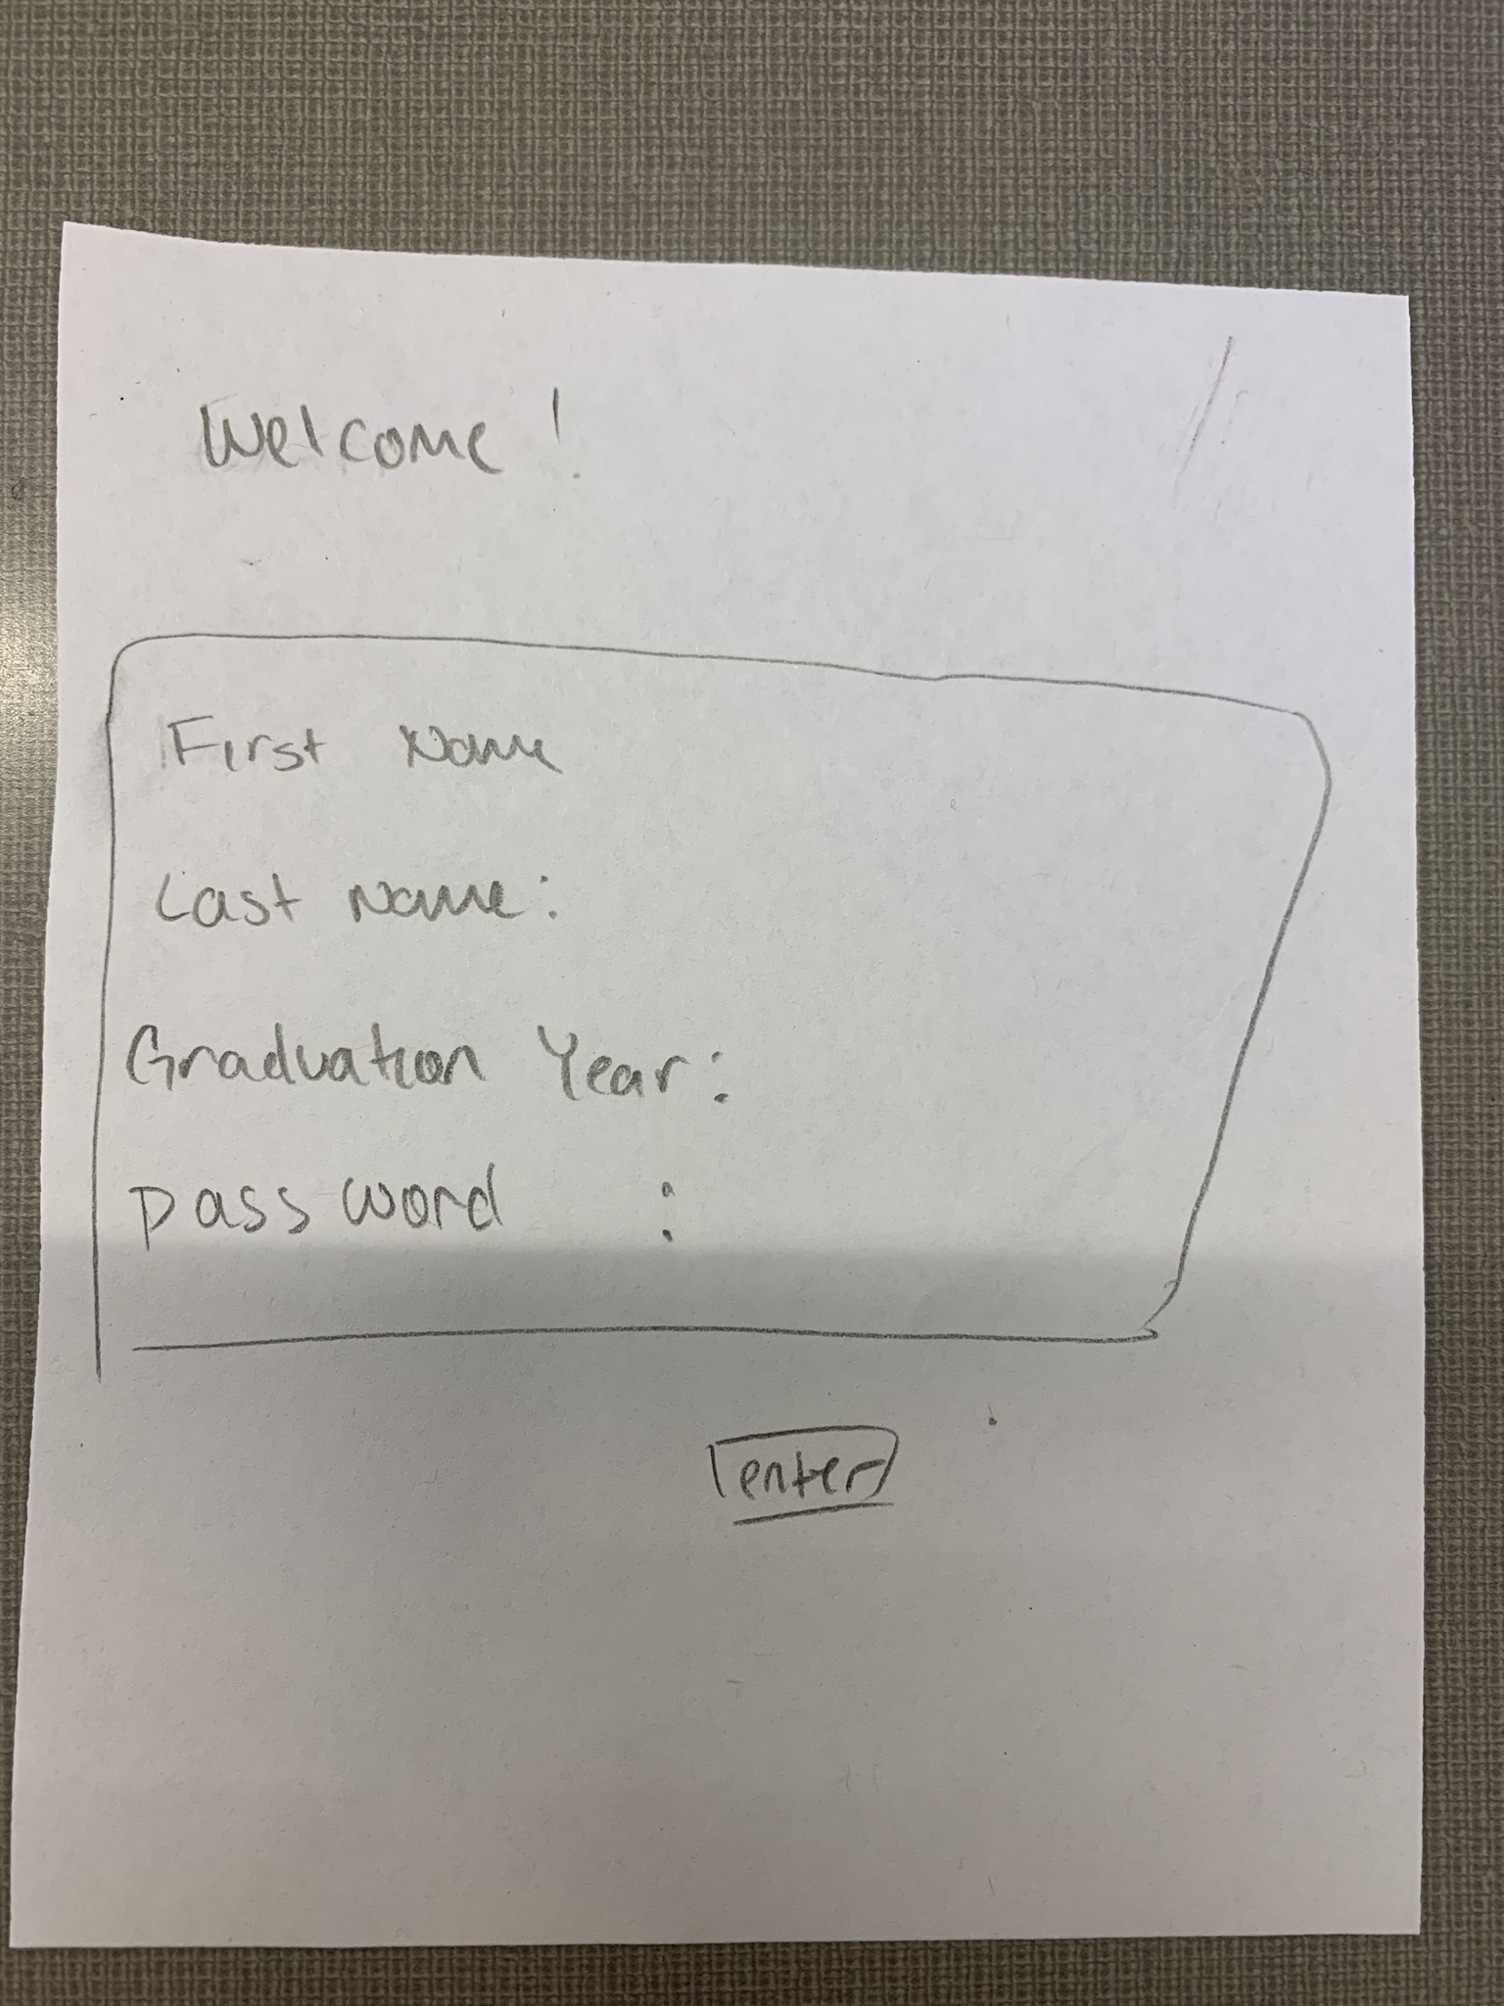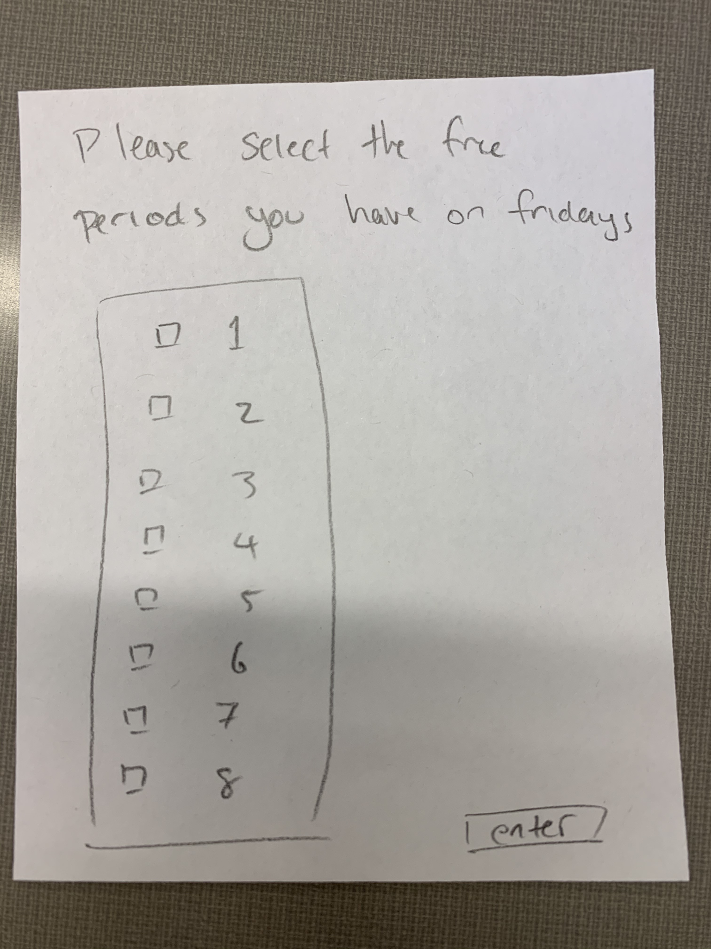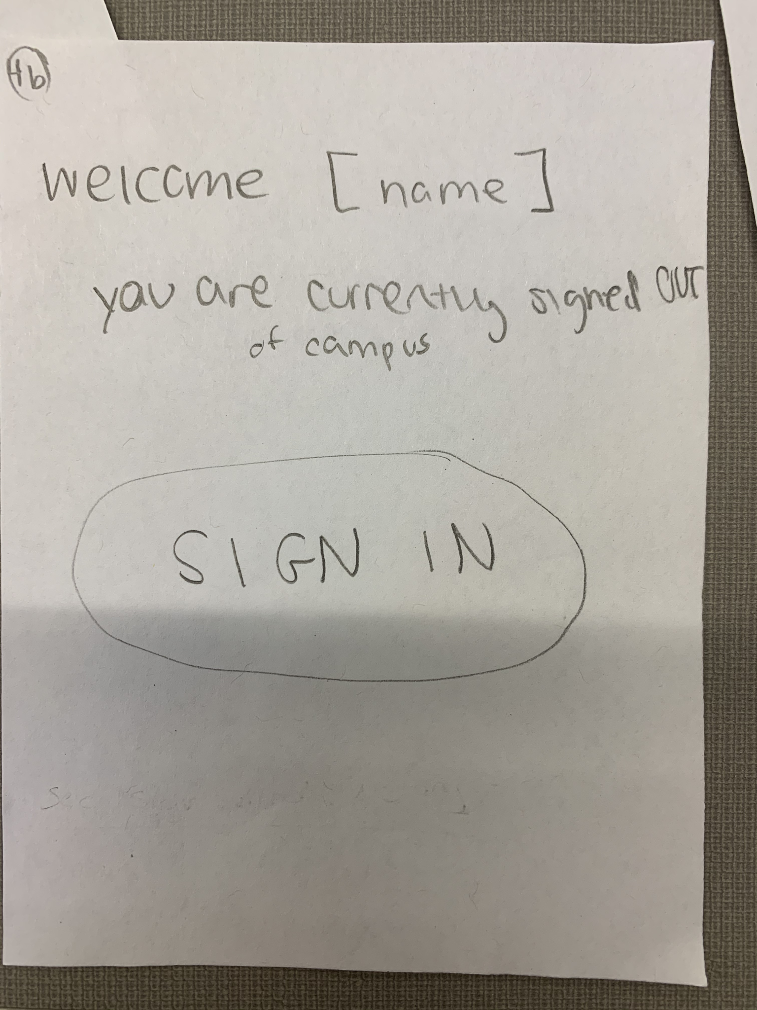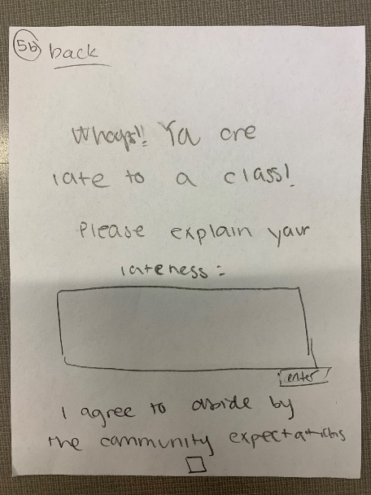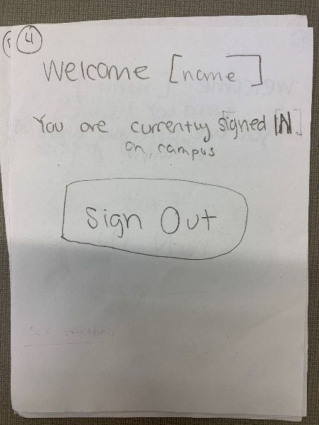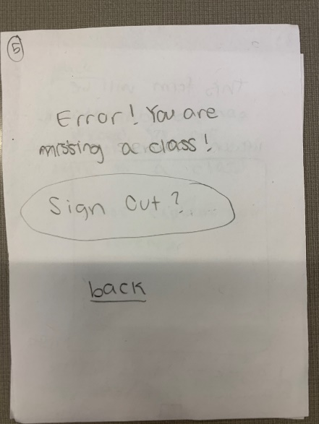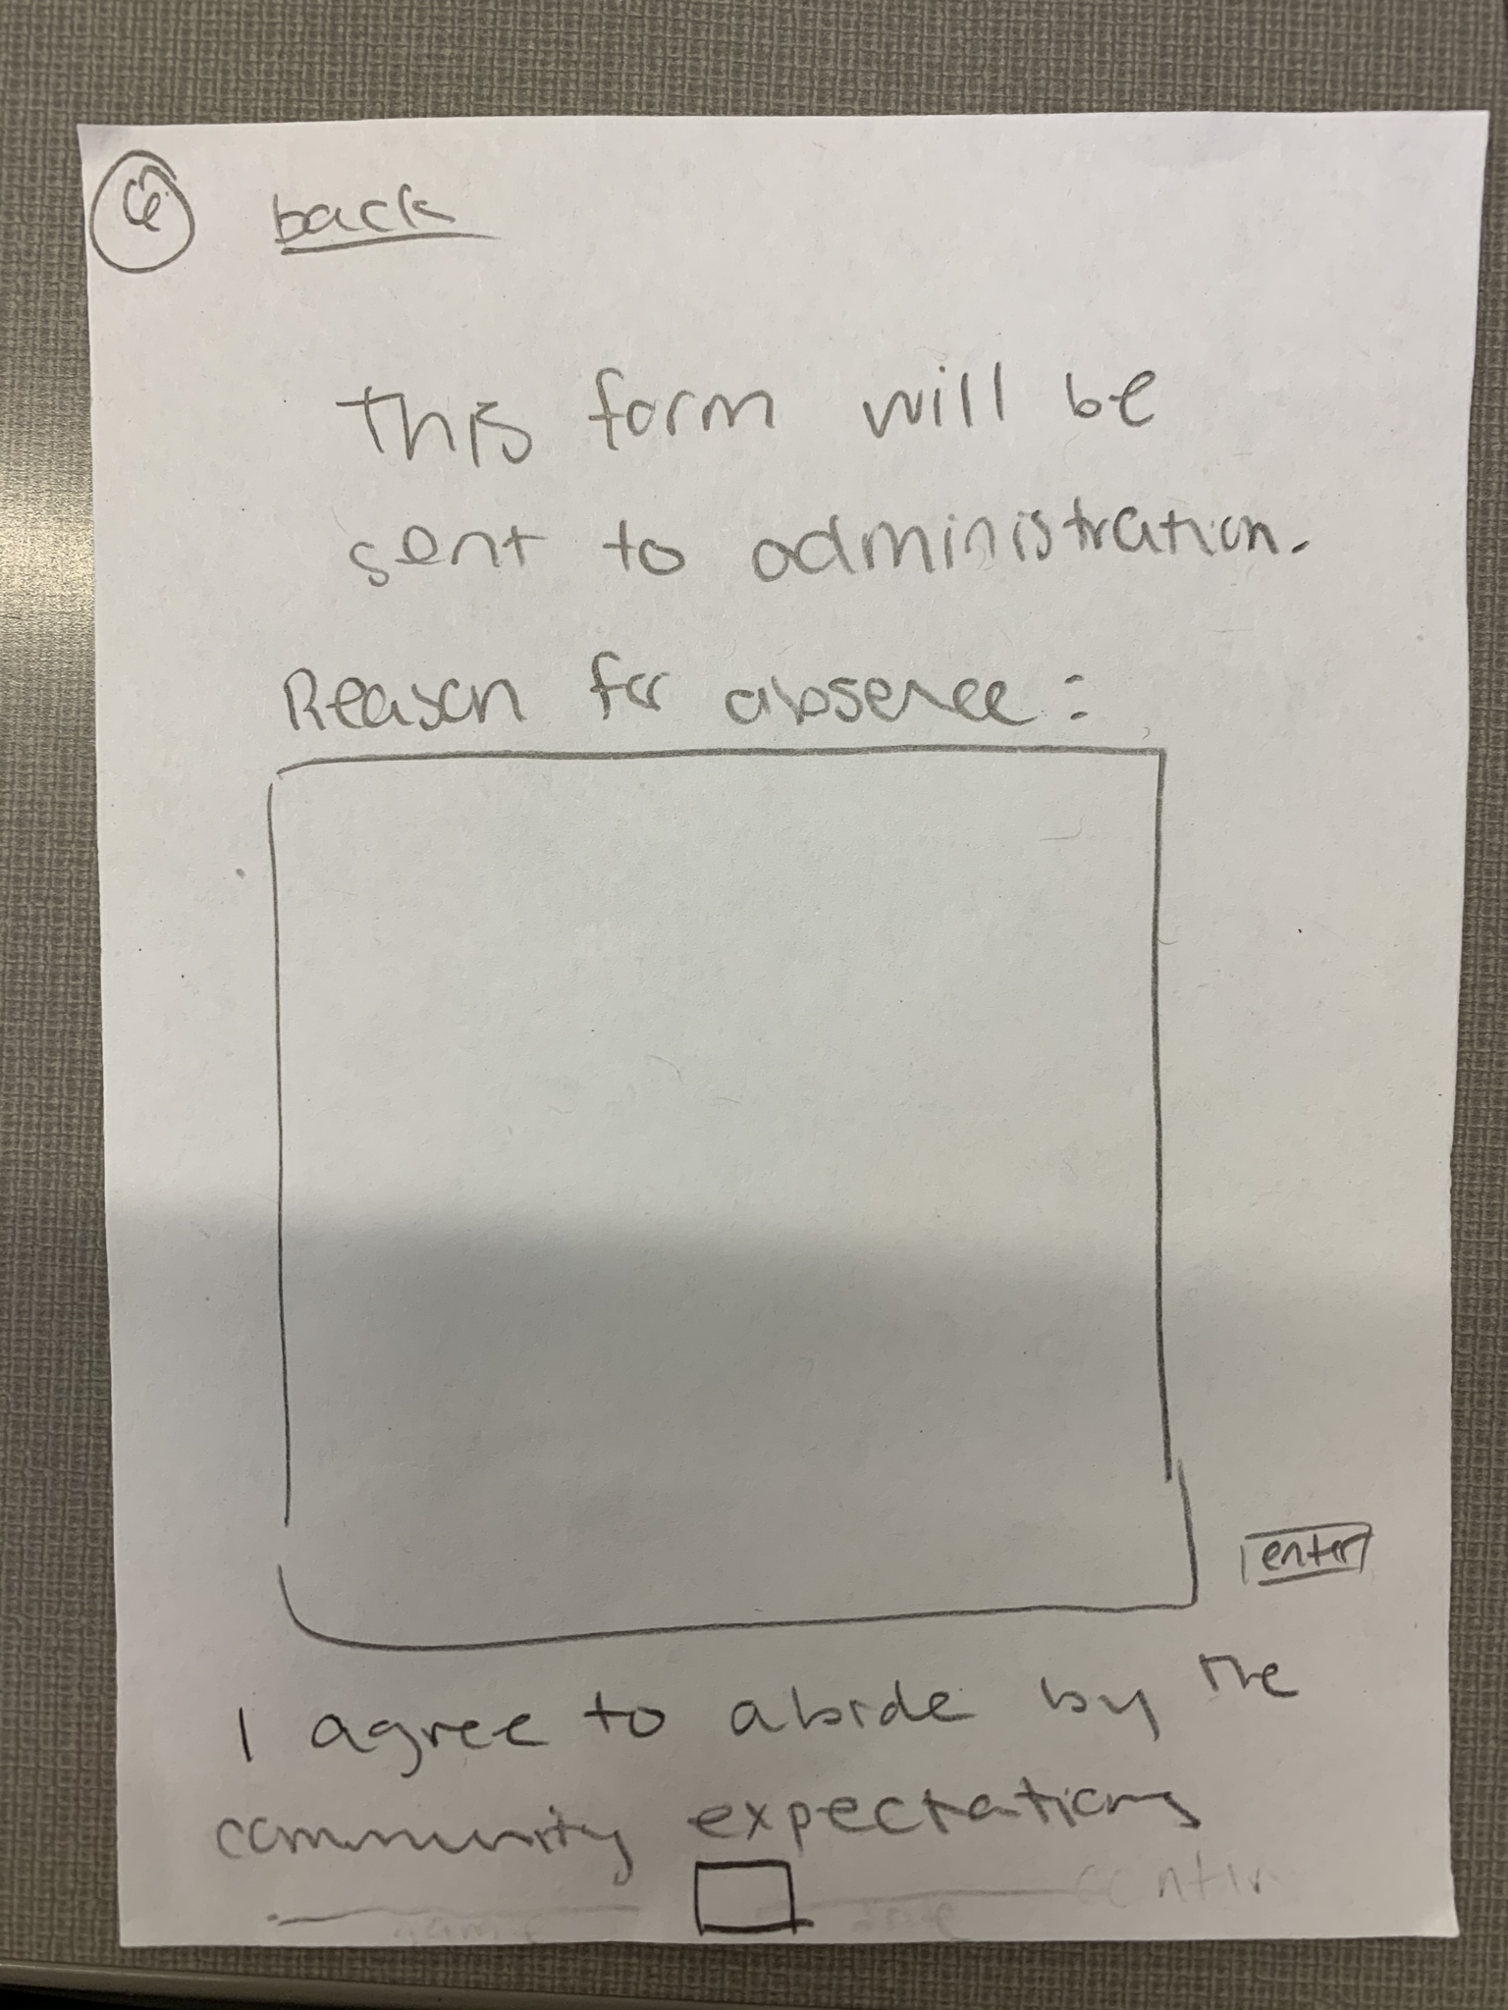
I talked with Adi, who suggested I make the “I agree to abide by community expectation” statements above the “enter” buttons on some of the forms.
I also talked with Vidisha, who reminded me I needed to include “back” buttons in case the user messed up or mis-clicked, and who also suggested the “I abide by community expectations” checkboxes.

Prioritization of Features
Will implement:
- Login page for returning users
- A way for new users to input information and get added to database
- Database to store login information, frees, and status (signed in/out)
- Website design (using popups for the confirmations, CSS)
- Time-sensitive design elements (resetting of sign-in/out status at 3:05 pm and checking the time the SIGN-OUT form is submitted to see if it conflicts with a class)
Will implement if time:
- Include a full day of the week schedule where each day has a unique schedule of frees
- Anything else I can think of…

Database Design
First database: id, first name, last name, login username, password, graduation year
Second database: login username, yes/no for 1st free, yes/no for 2nd free, yes/no for 3rd free, yes/no for 4th free, yes/no for 5th free, yes/no for 6th free, yes/no for 7th free, yes/no for 8th free
- If I decide to implement a unique schedule for Monday-Friday, instead of just keeping track of Friday schedule frees, I will most likely need to include more databases (perhaps one for each day of the week) to keep track of them all.
Third database: login username, sign-in status

Proposed Implementation Schedule:
October 29: Milestone 1: Design document due
November 8: Finish the HTML outline of the entire site plus database (with redirecting, etc.)
November 11: Finish fleshing out the details of HTML (database, storing information, pulling out information, etc.)
November 12: Start testing the website with other people
November 14: Milestone 2.5 – teacher check-in
November 15: Hopefully get the HTML stuff working 100%
November 22: Implement CSS
November 25: Continued testing/fine-tuning of details
November 27: Testing day – project 99% done and can be tested in class
December 6: Web Project due!
December 9 –13: Milestone 3 – work on presentation and get it ready for whenever I have to present in class

Potential Showstoppers
The only challenge I can think of would come from trying to implement the time-sensitive design element

Open Questions:
N/A

