Will MacCormack
CS 4
Ms. O’Neal
30 October 2019
Web Project Design Document

Functional Overview:
Vix, pronounced with a w, is a drag and drop website design tool that takes care of front-end HTML and CSS development. Vix allows users to sign in to save progress of their web designs, share finished designs on Vix and export the HTML and CSS of their finished site. Vix is for anyone who wants to have a simpler web design experience and works for both the experienced and novice web designer.

Design Overview:
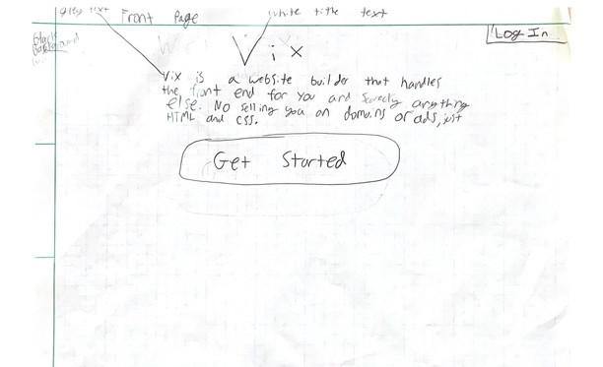
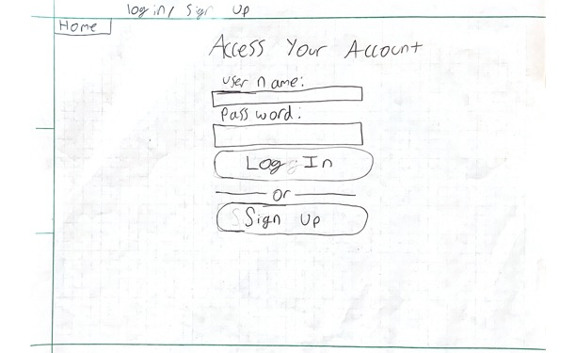
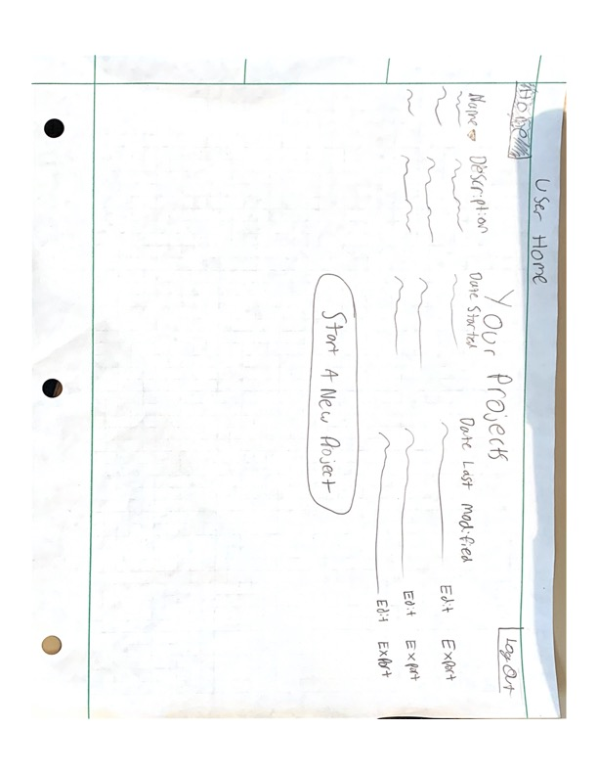

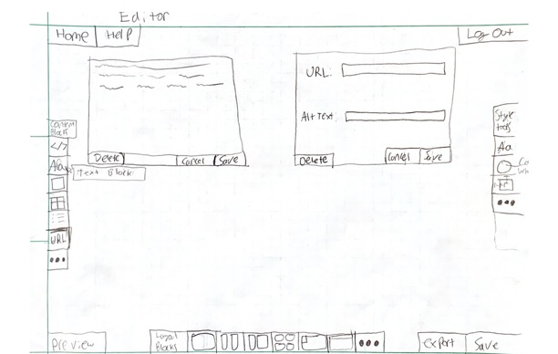
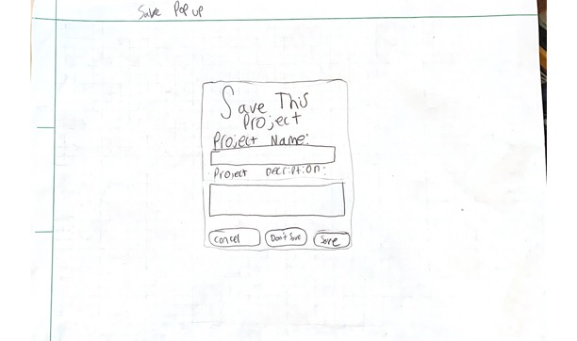
Design Testing Results:
Vincent and William tested
Changes:

- Add Presentation mode/Fullscreen
- Save, Export, and Preview buttons on editor
- Description of icons w/ hover text
- Toolbars are Labeled
- Add link block to toolbar
- Add Description to list of your projects
- Sort your projects by categories
- Grey out home when on page
- Help tool
- Edit and Export links in your projects view

Prioritization of Features:

Definitely Will Implement
- Drag and Drop HTML “Block” Placement
- Block styling and Content Editing
- Website Exporting
- User Sign In/Saving and projects page

Will Implement If I Have Time
- Made With Vix
- Website Sharing/Social aspect
- Block and template favoriting/saving
- JavaScript styling blocks

Database Design:
- Users
  - Id
  - Username
  - Password
- savedWebsites
  - id
  - userId
  - name
  - description
  - dateStarted
  - dateLastModified
- savedBlocks
  - id
  - userId
  - htmlContent
  - cssAttached
- websiteToBlock
  - id
  - websiteId
  - blockId
  - parentBlockId
  - order

Proposed implementation schedule:
- 10/30 Start on Actual Project
- 11/8 Drag and Drop for basic html done
- 11/14 Layout drag and drop
- 11/18 CSS styling tools
- 11/20 Website exporting
- 11/27 Sign in saving system done
- 12/6 Fix bugs that are found

Potential Showstoppers and Open Questions:
- Drag and drop is impossible or ludicrously difficult.
- Block system will not work and whole html pages will need to be saved instead

