Design Document

Functional Overview
- The intended users are anyone who is interested in learning about the elements, but most likely students of chemistry
- The main feature is an interactive periodic table that allows the user to learn about the elements by hovering over and clicking on each element.
- The user can also filter which elements are highlighted by group, period, type (metal, non-metal), and phase at room temperature
- The website will read data about each element from a file
- If the user creates an account, they can select certain elements to study, and the website will create flashcards that highlight important features of each element
- Bonus: the user can type in their name or another word and the website will see if the word can be composed of elemental symbols
  - Libby = LiBBY = LithiumBoronBoronYttrium
  - Sophia = not possible

Design Overview
Opening Page
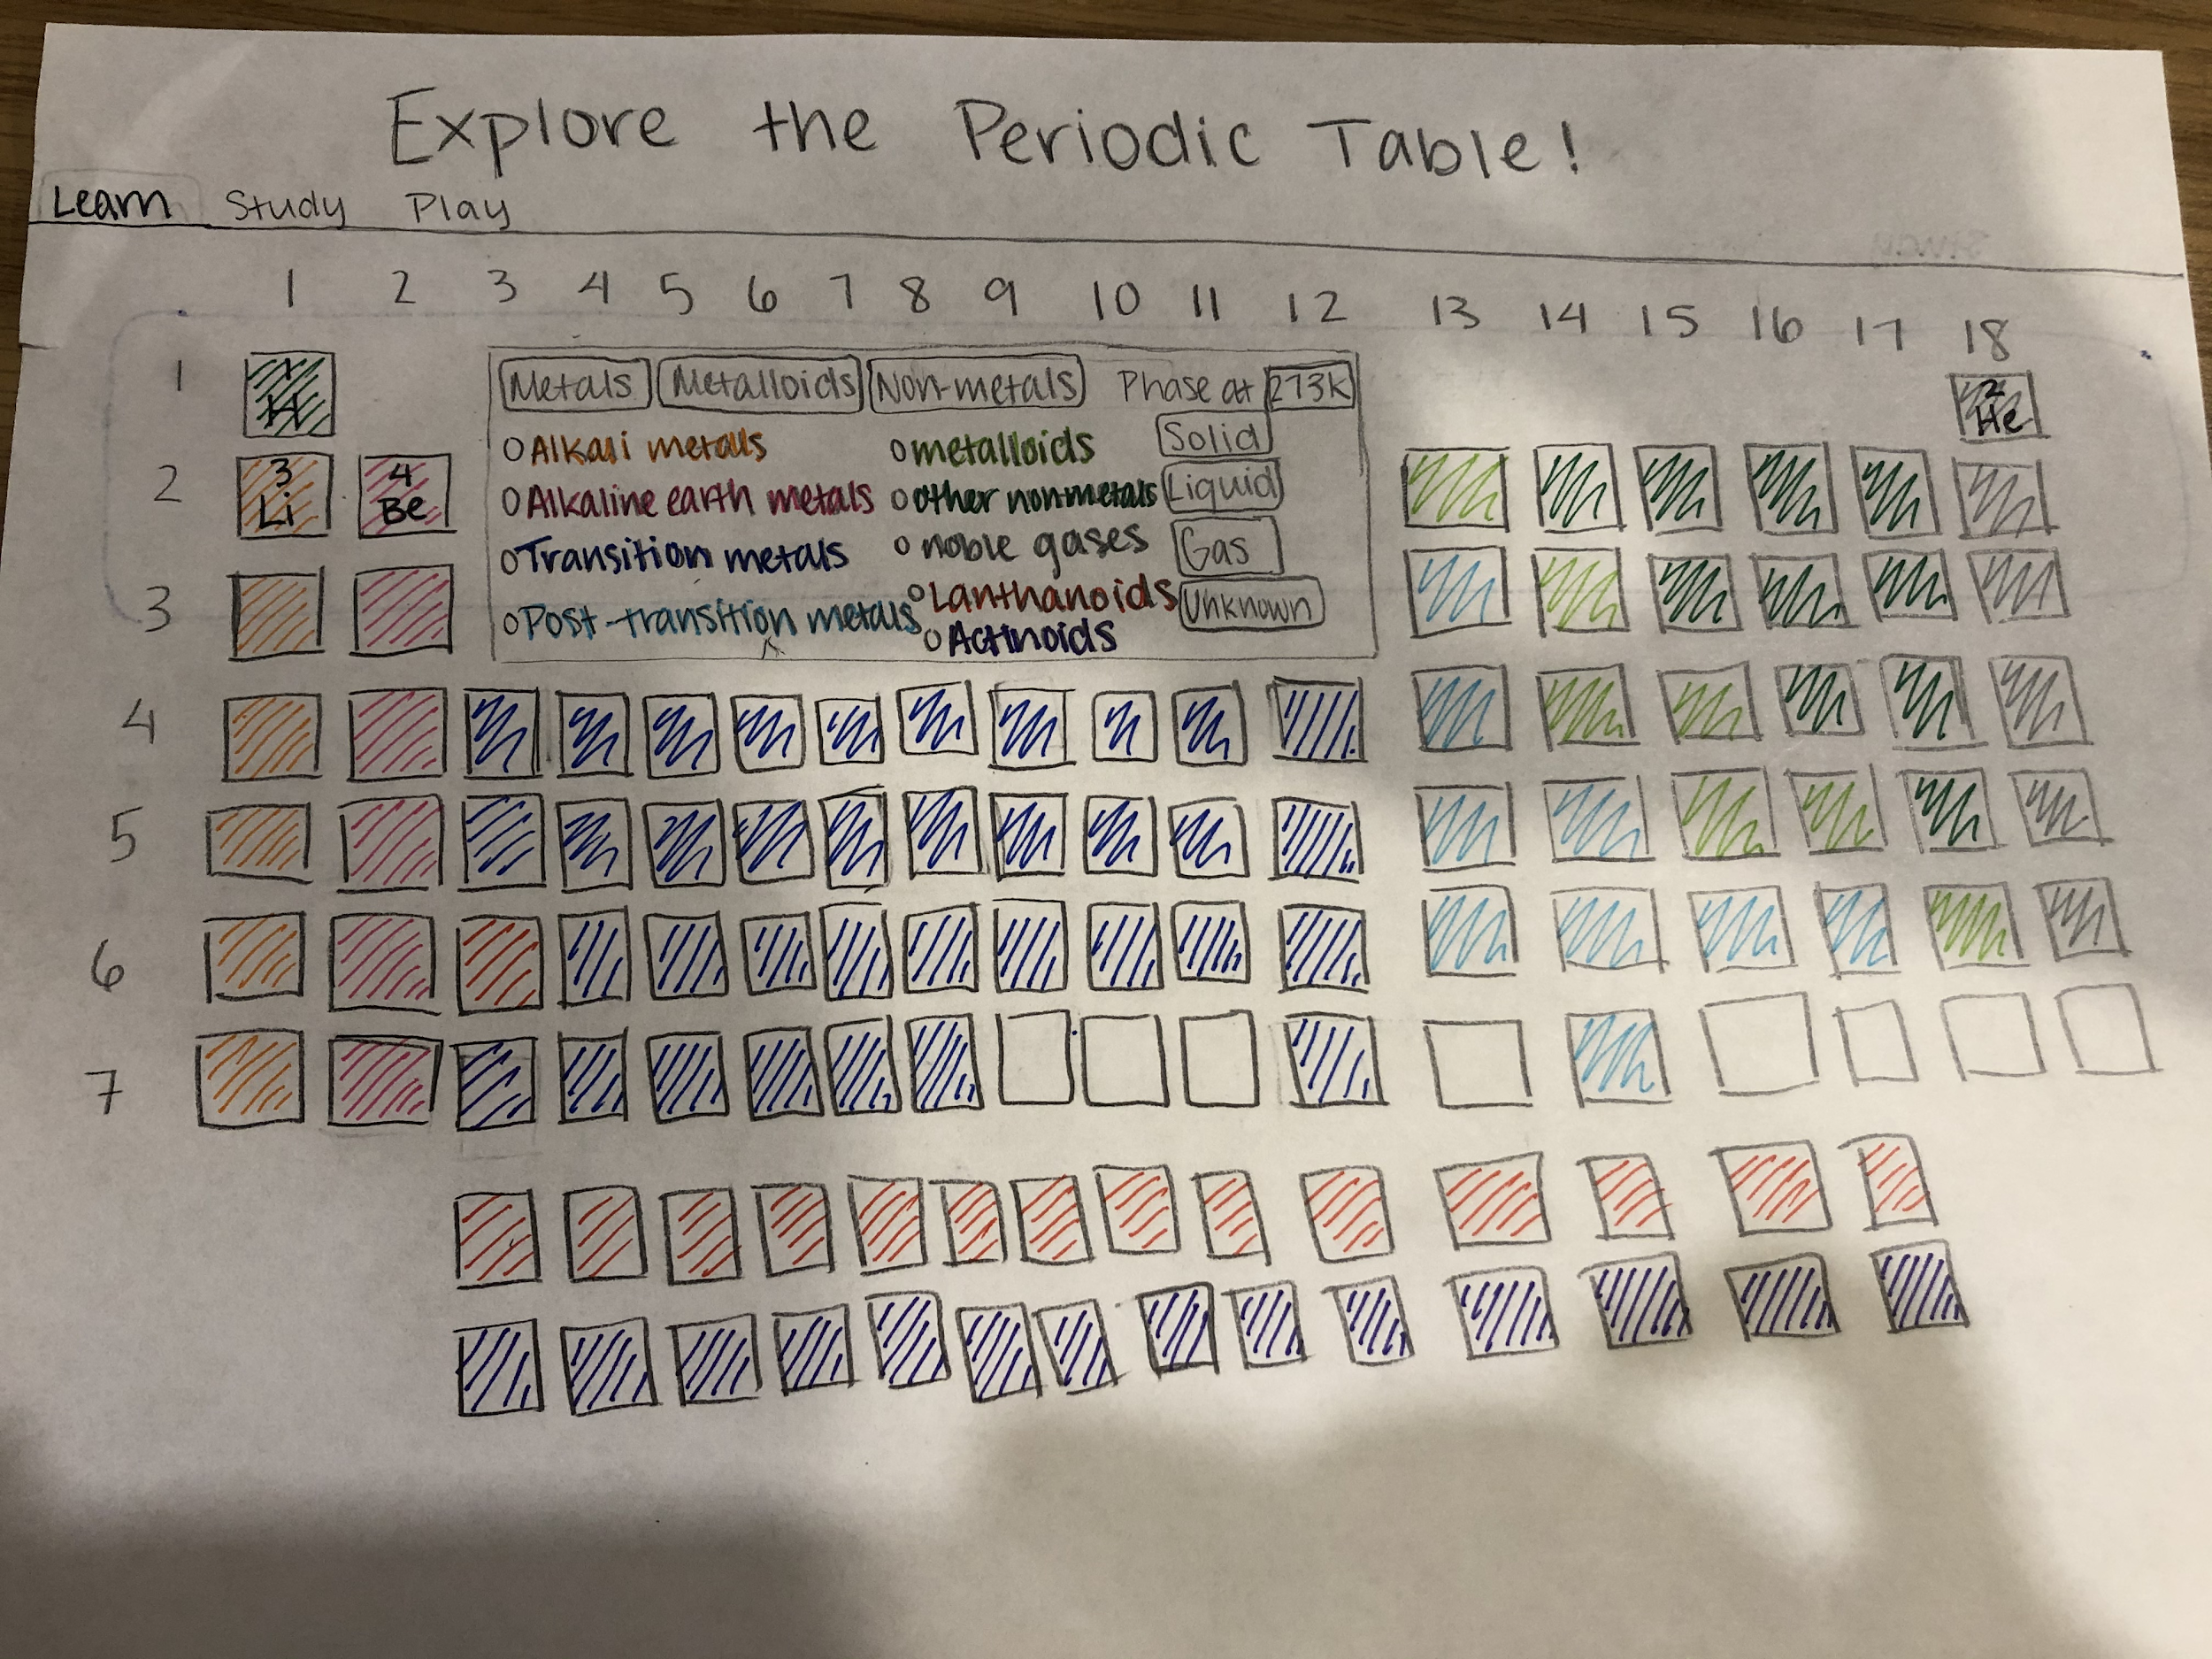
If element is clicked
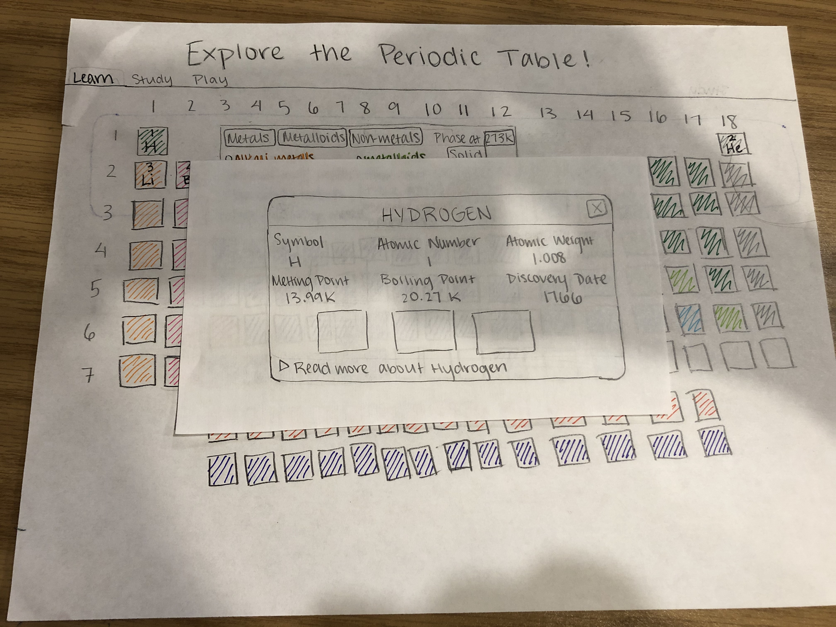
If “read more” is clicked
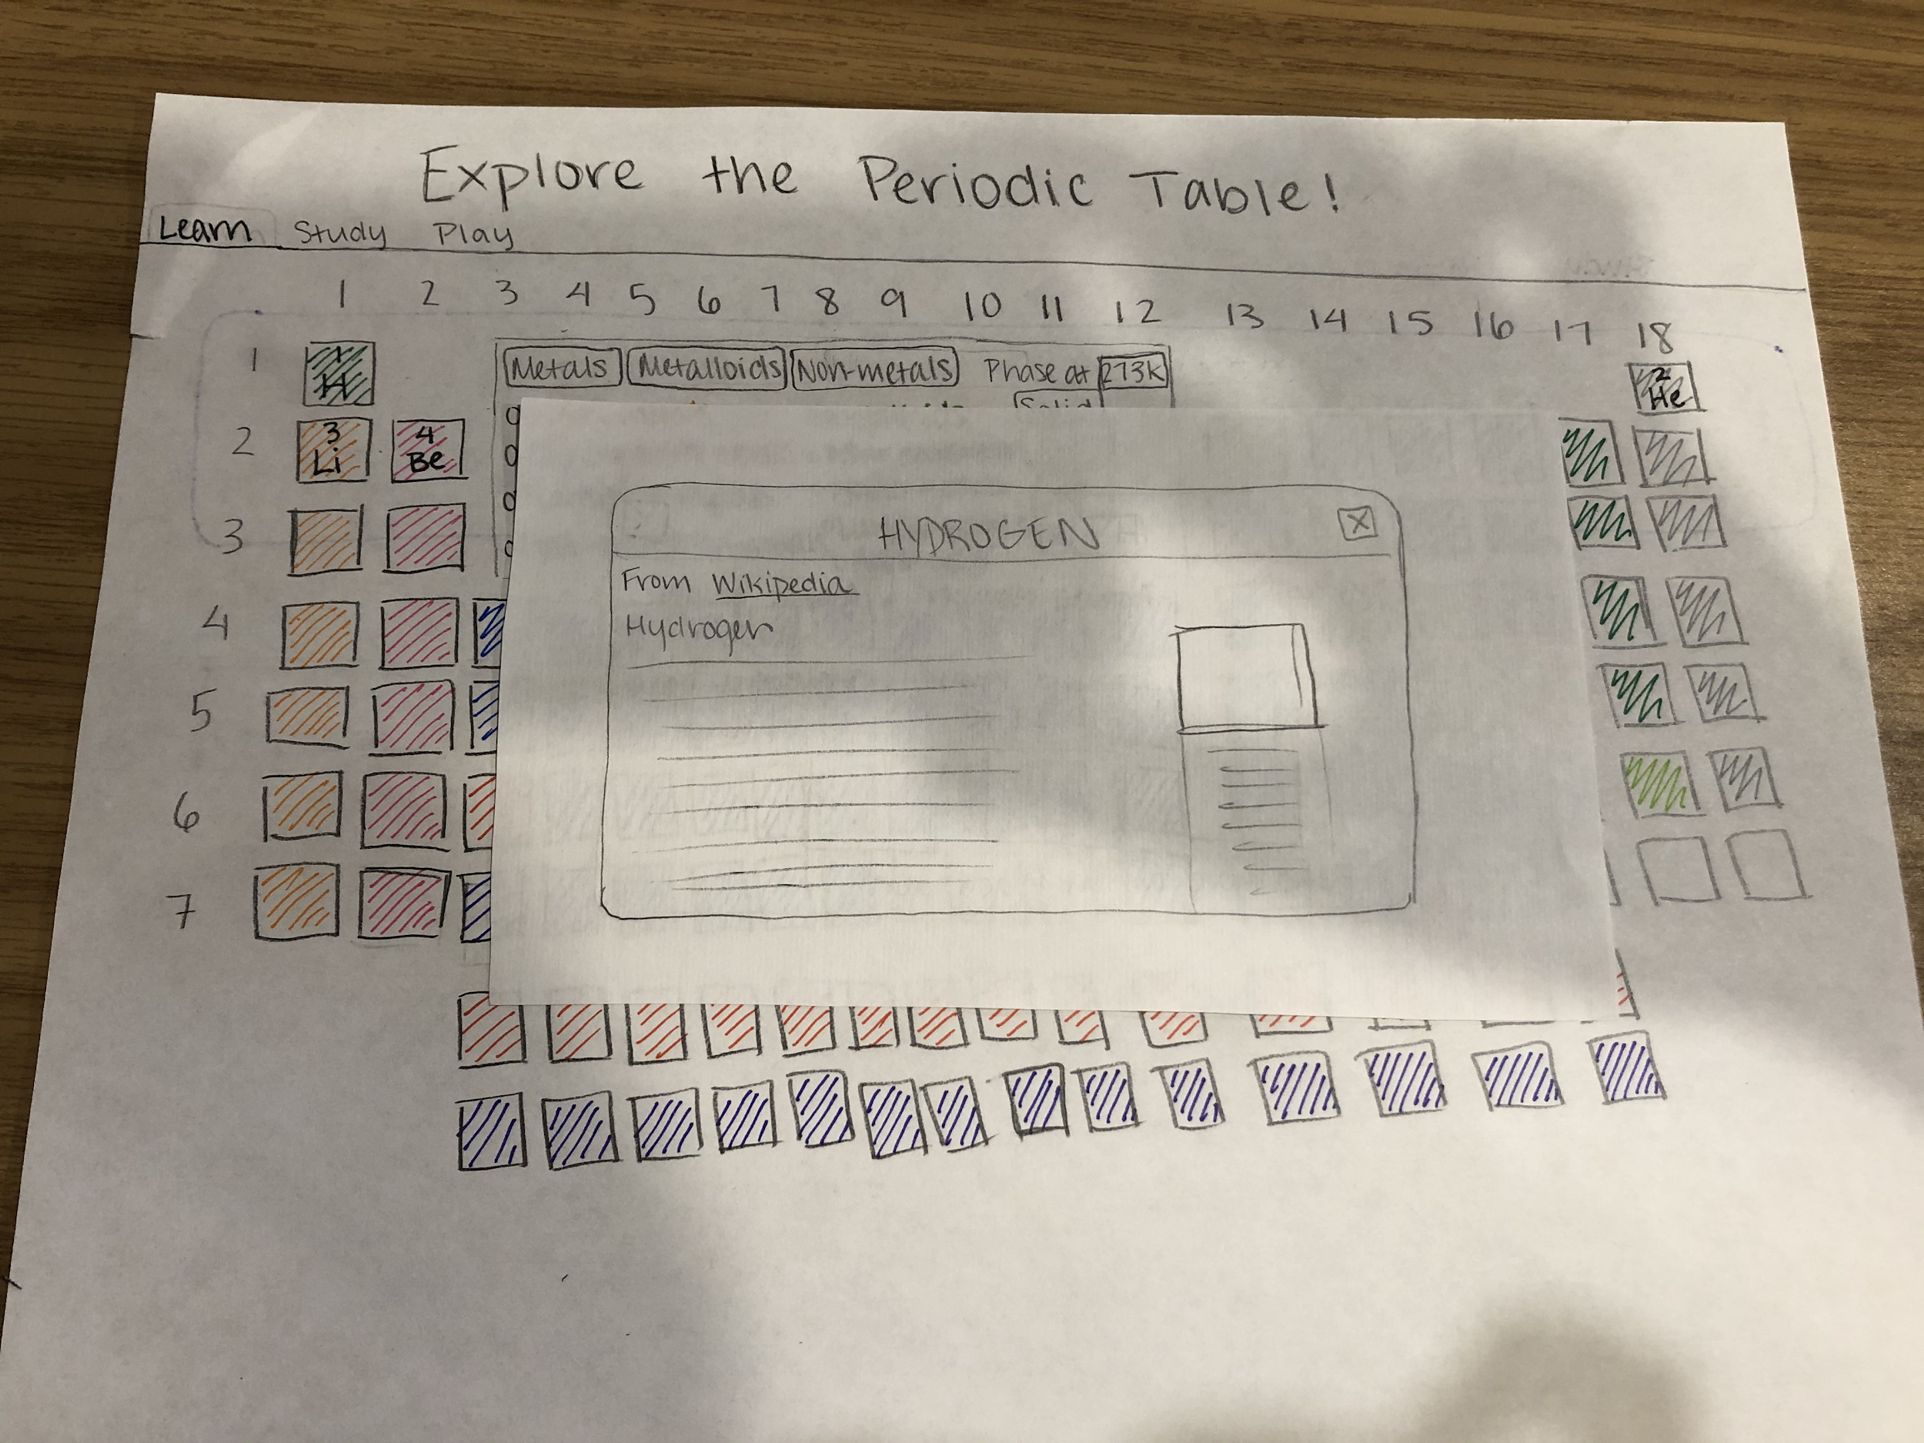
If group or period is clicked
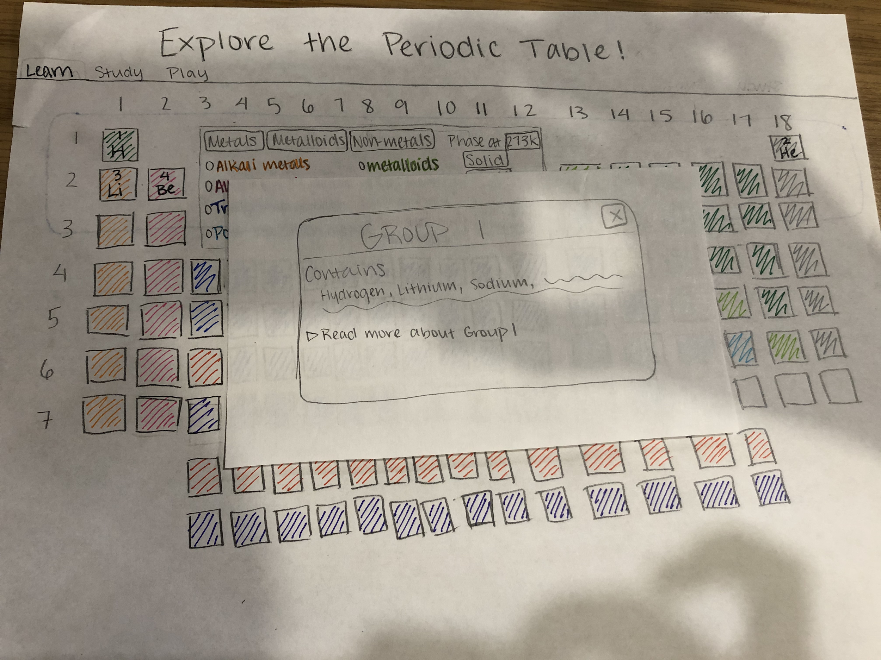
If category filter is clicked
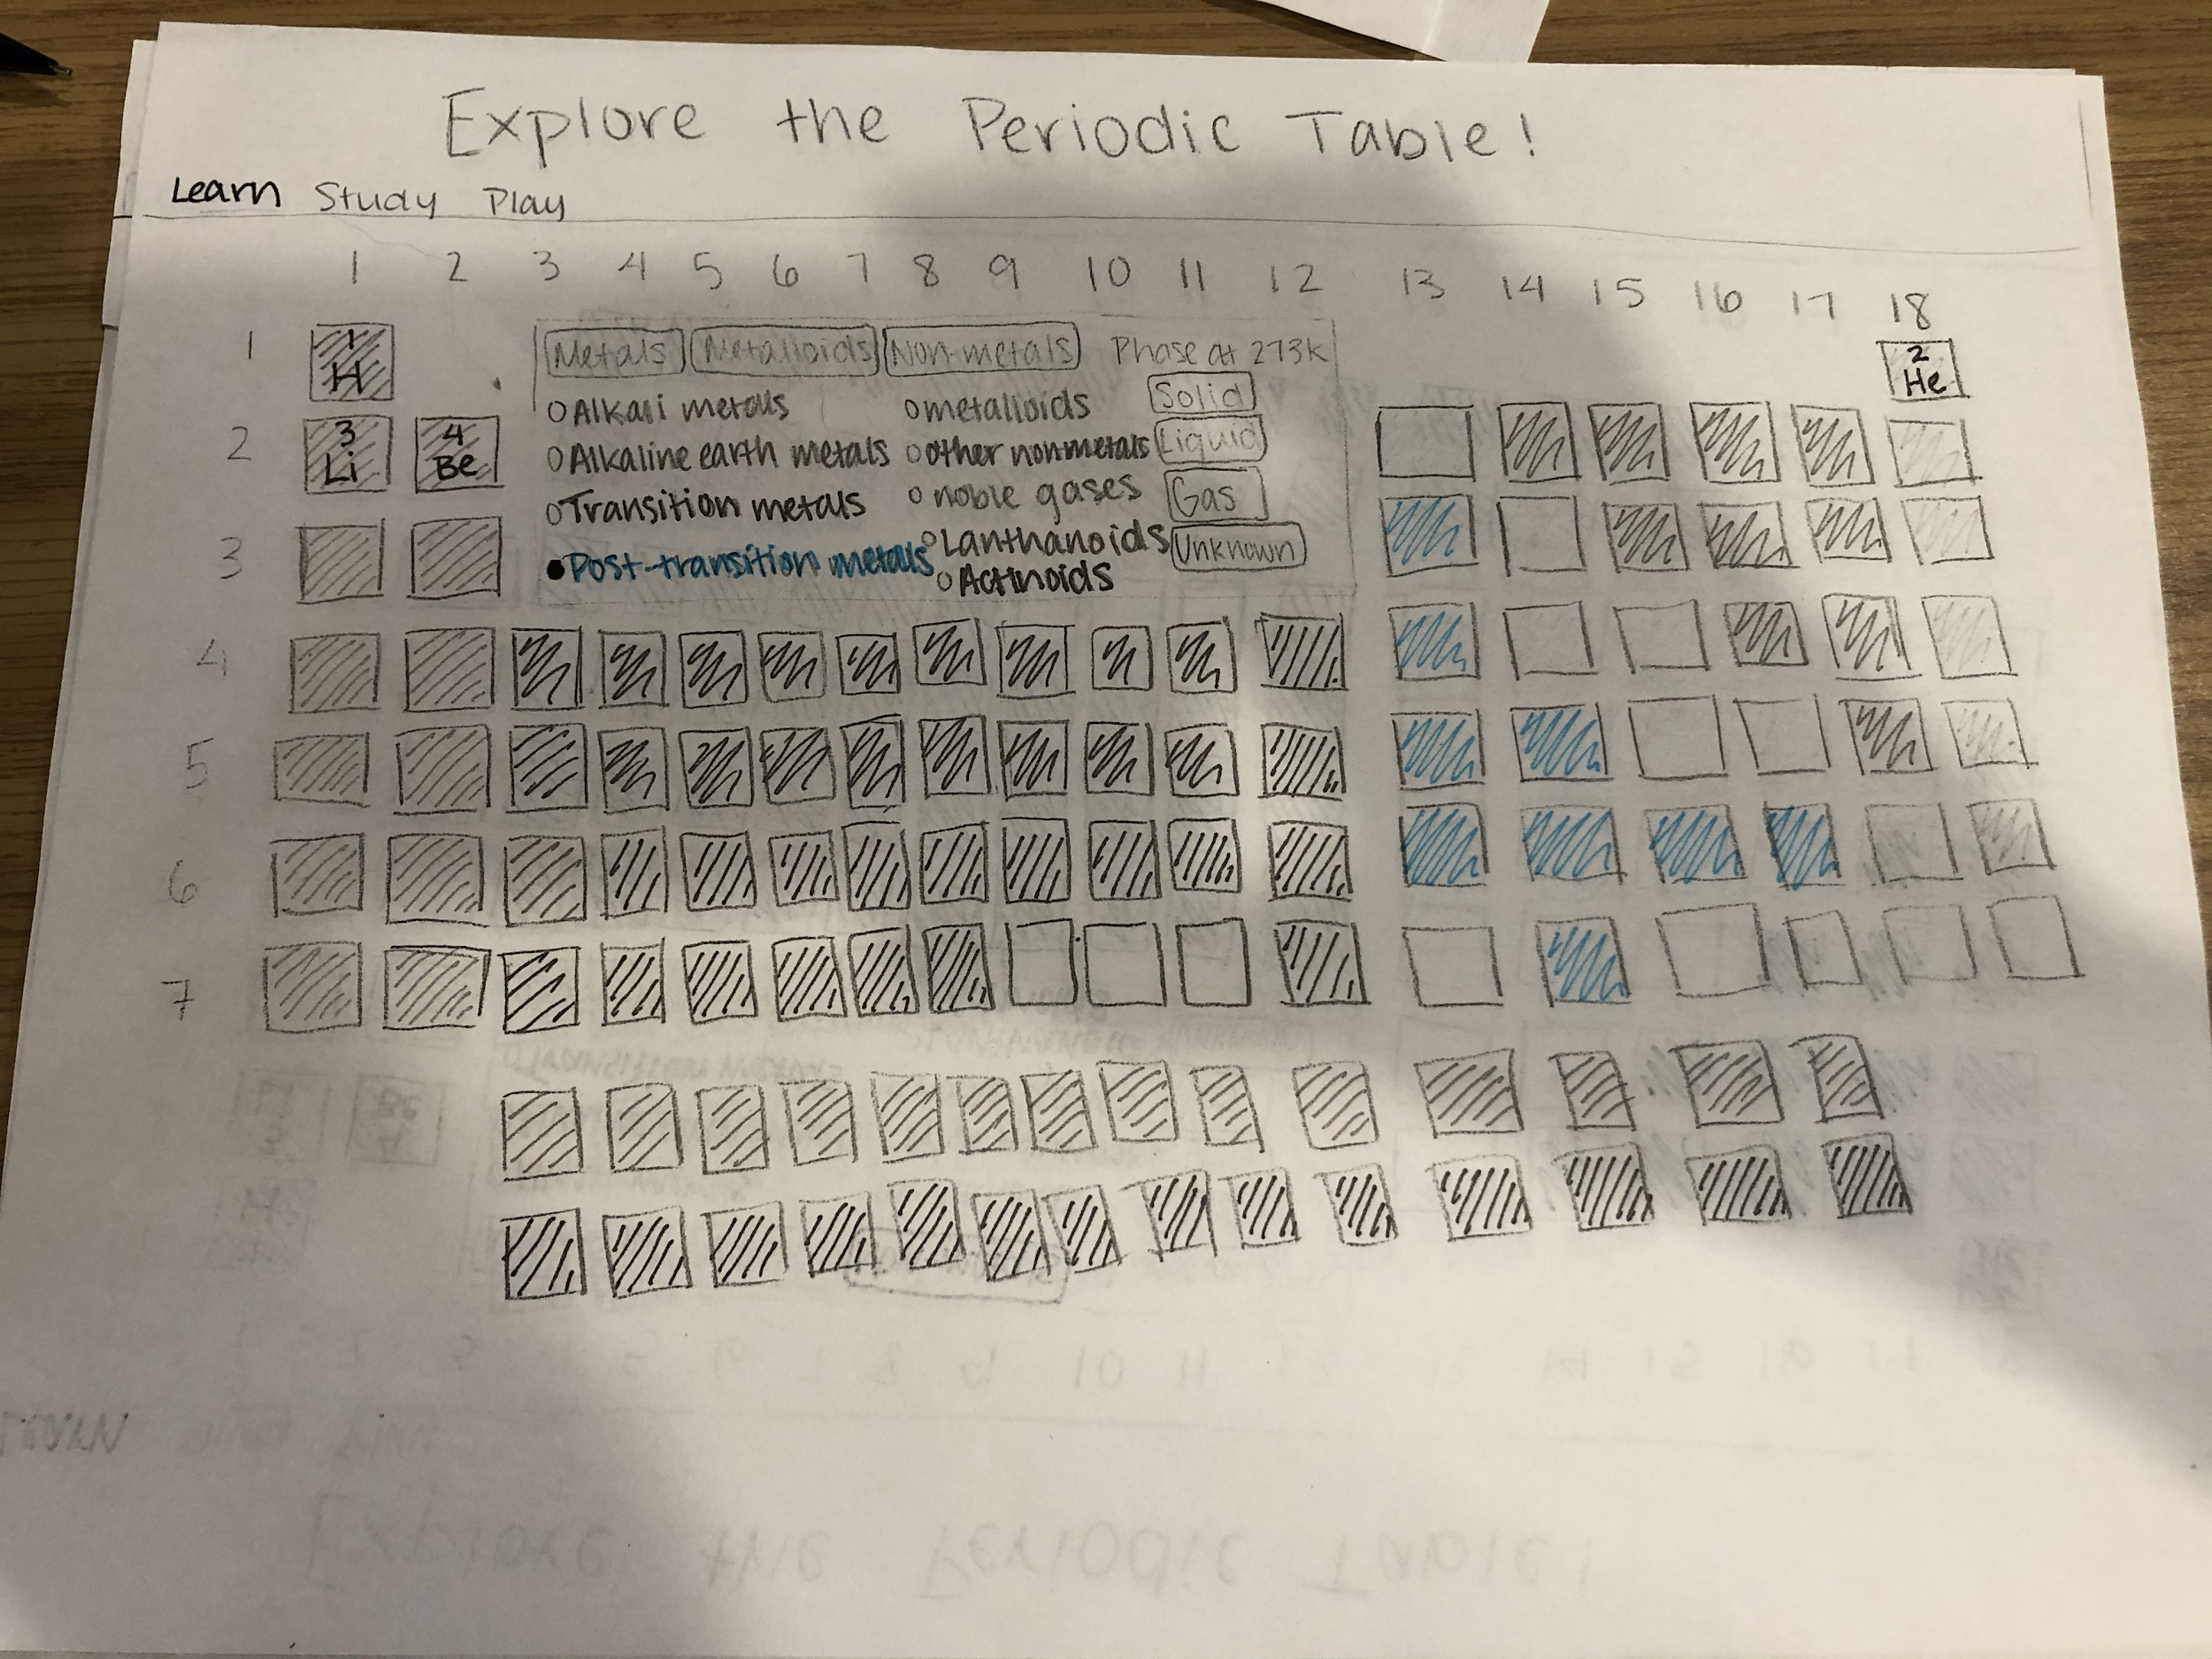
If broader type filter is clicked
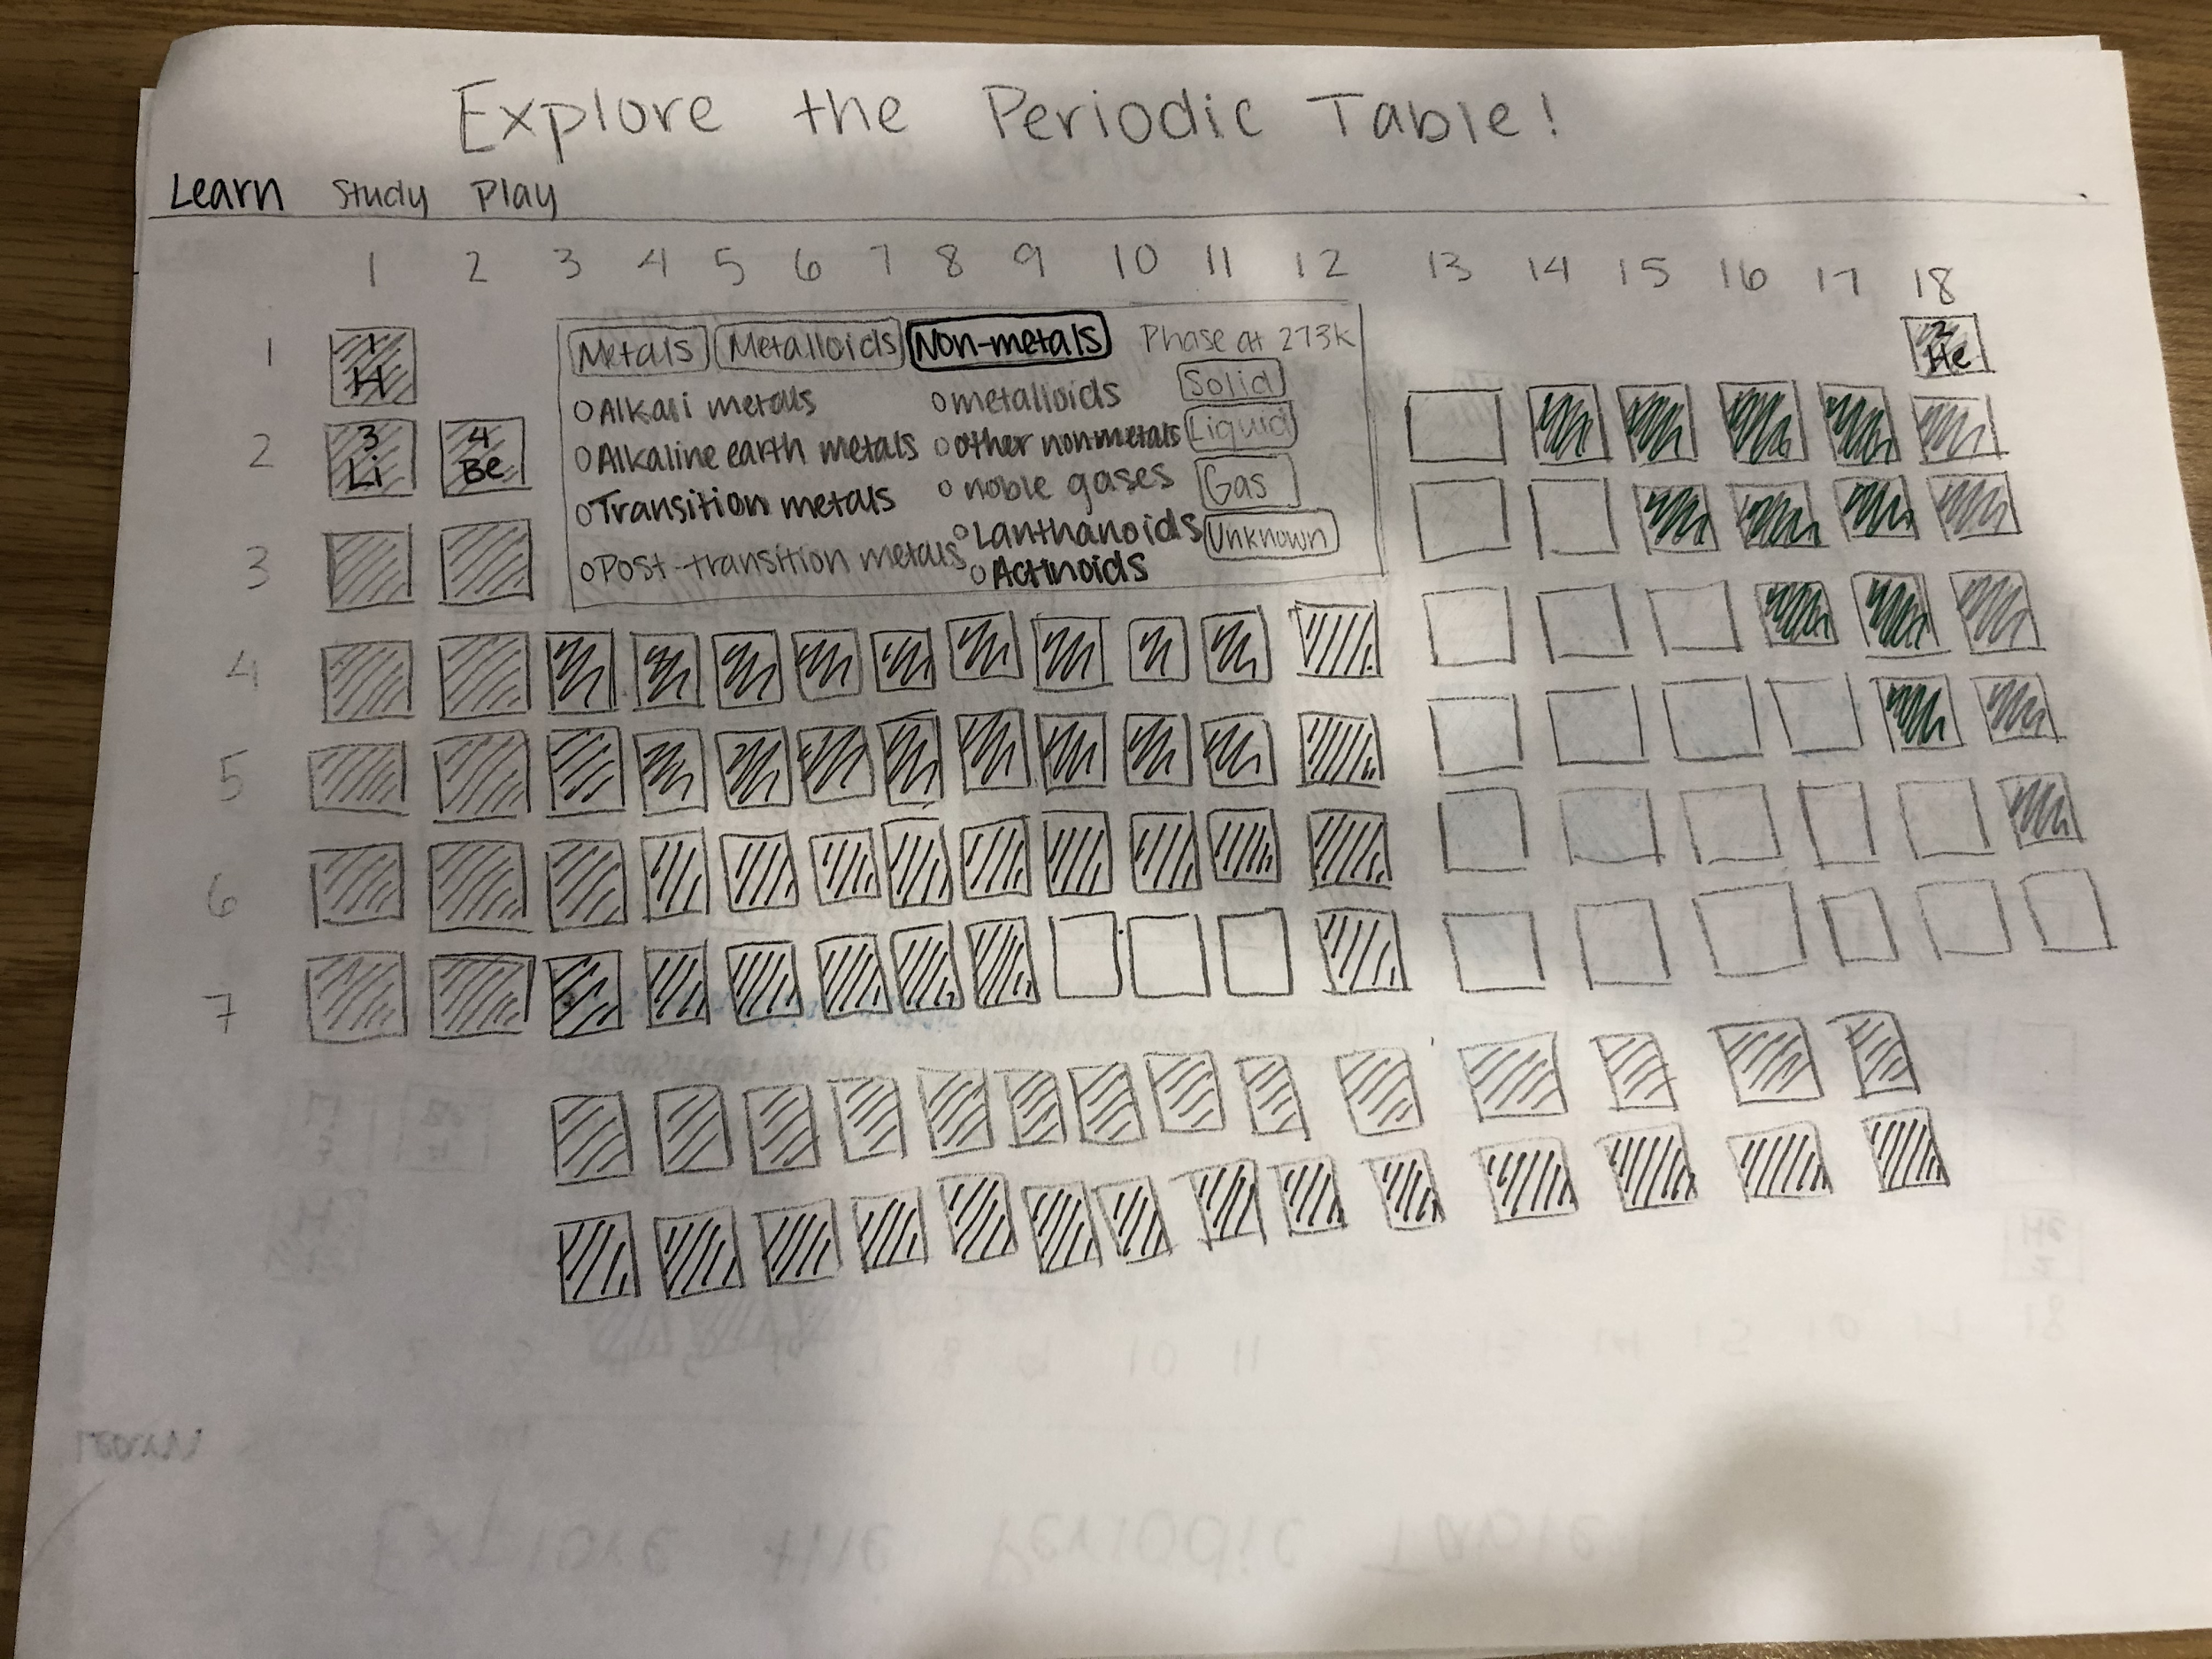
If phase filter is clicked
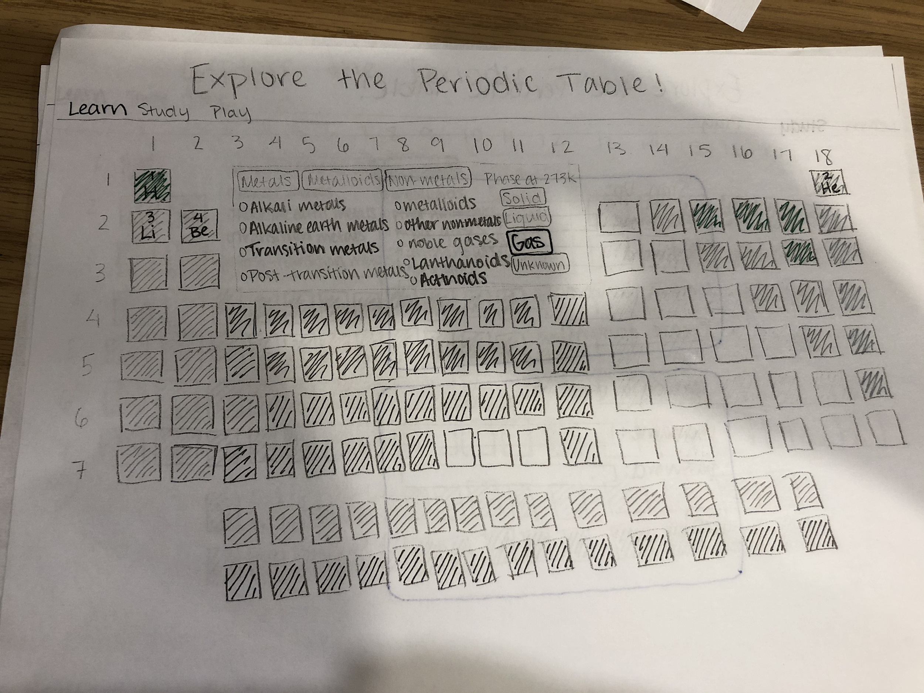
Study page log in
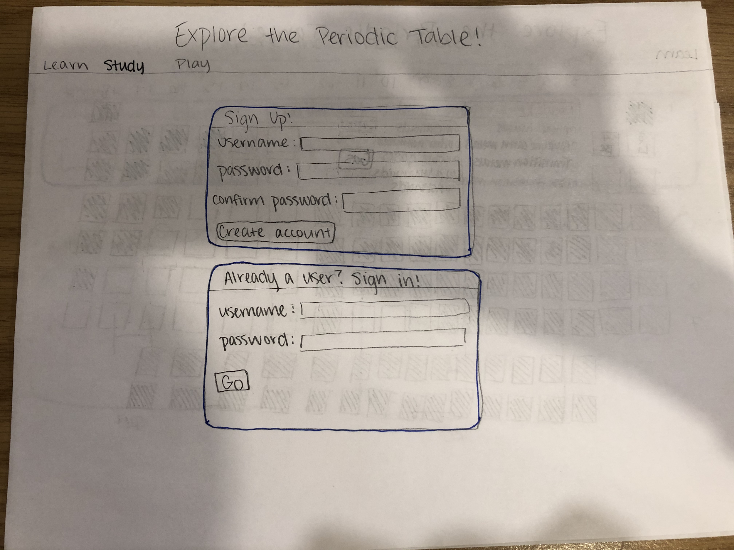
Main study page/flashcards
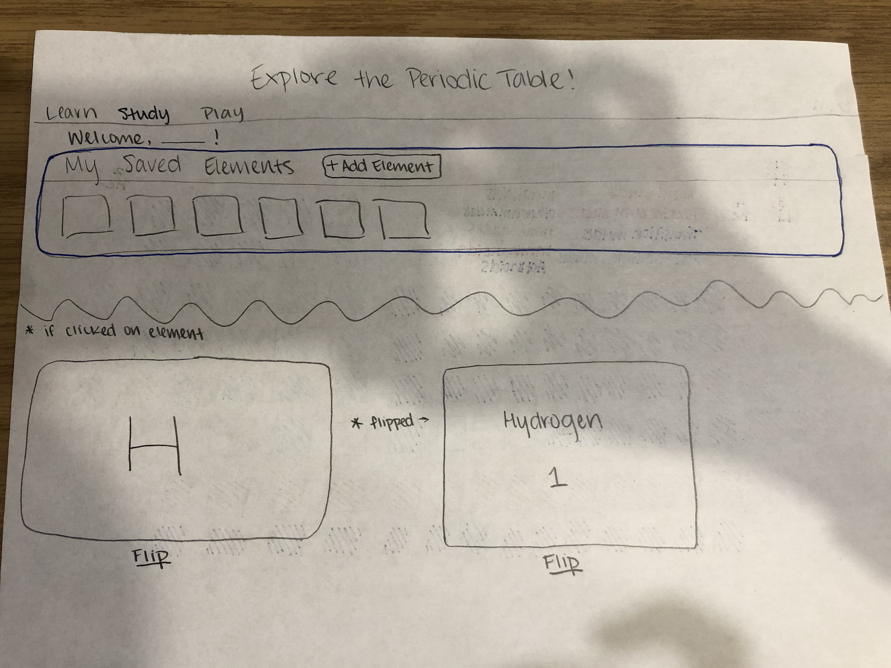
Element select page
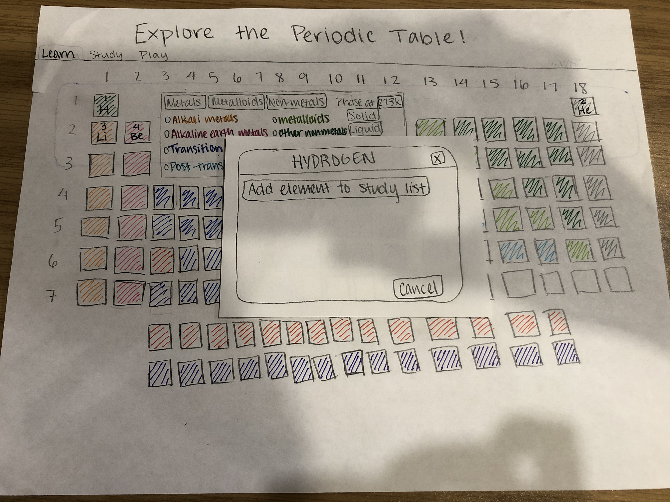
Game page
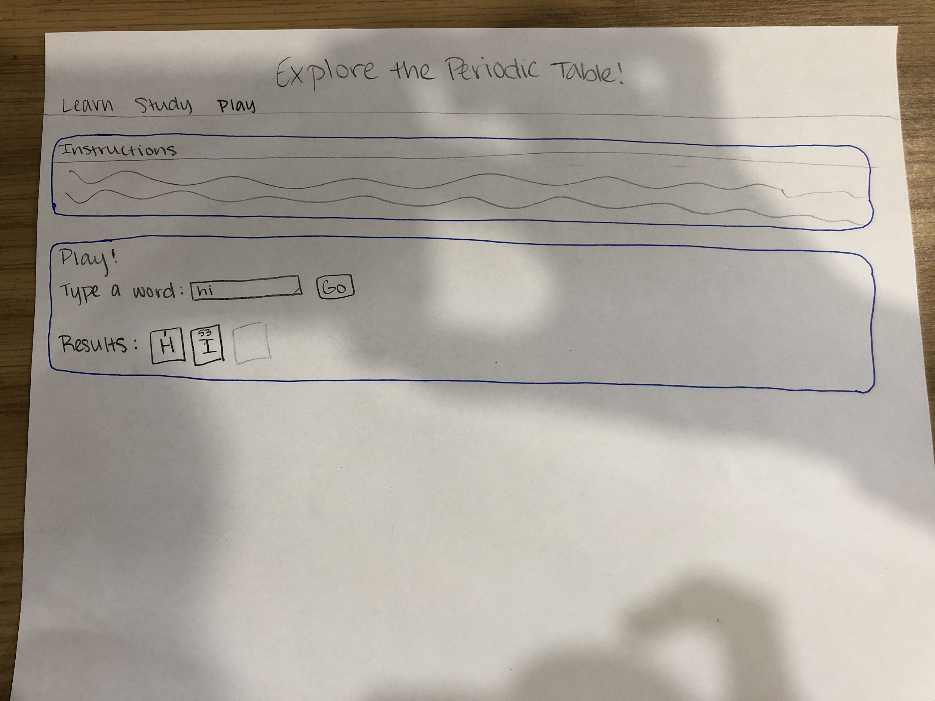

Design Testing Results
- Libby - create a way to select multiple filters at once and allow the user to deselect them by clicking on it again; maybe allow the user to change the temperature where phase is determined; add an ‘x’ to close the element info boxes
- Jane - give the user a way to save/favorite specific elements

Prioritization of Features
- Will Definitely Implement
  - Reading a file to gather information about elements
  - Element icons in the shape of the periodic table that can be clicked on
  - Filter elements by category, group, and period
  - User login
  - Allow users to indicate favorite elements for studying
- Will Implement if Time
  - Show the element’s Wikipedia page
  - Filter elements by phase at room temperature
  - Filter elements by phase at temperature set by user
  - Create flashcards for users to study their stored elements
  - A “game” where the user can type a word and the website tries to build it out of elemental symbols

Database Design
- Elements (stores information about each element)
  - Atomic number
  - Name
  - Symbol
  - Atomic weight
  - Group
  - Period
  - Category
  - Melting point
  - Boiling point
  - Description
  - Wikipedia link
- Users
  - Id
  - Username
  - Password
- Users to elements
  - User id
  - Atomic number

Proposed implementation schedule
11/5: Store element info in a database
11/11: display the elements in the shape of the periodic table
11/14: Show element details when clicked on, embedded Wikipedia page
11/19: CSS for main page
11/22: User login, adding elements to study list (database tables)
11/25: CSS for studying page
11/27: Flashcard display
12/4: Word-building game

Potential Showstoppers and Open Questions
I’m not really sure what to do about reading the file - do I read it once and store the info in a database? Or do I look through the file every time I need information?
How do I make the element blocks trigger the text box?

