Roman Short
Comp Sci 4
Design Document for Final Project

Functional Overview:

This will be a website for my company, Re-Balloon, which I am working on with Kelly Wang and Stricky Kellogg in Business and Entrepreneurship class. The intended users are myself and my co-workers, and our customers – following CS4 if our company is successful we could implement actual payment systems and ordering processes.

Design Overview:

Note – specific colors will be chosen later; I’ll do this with Kelly and Stricky. 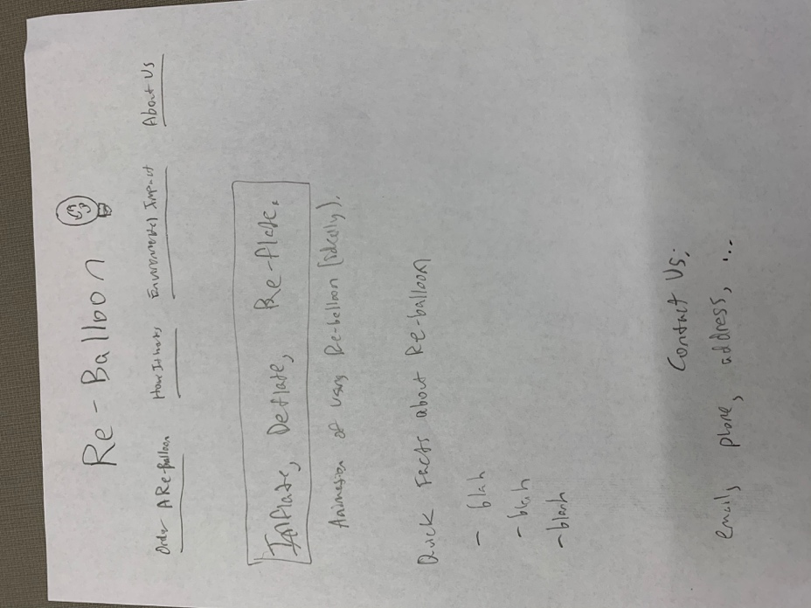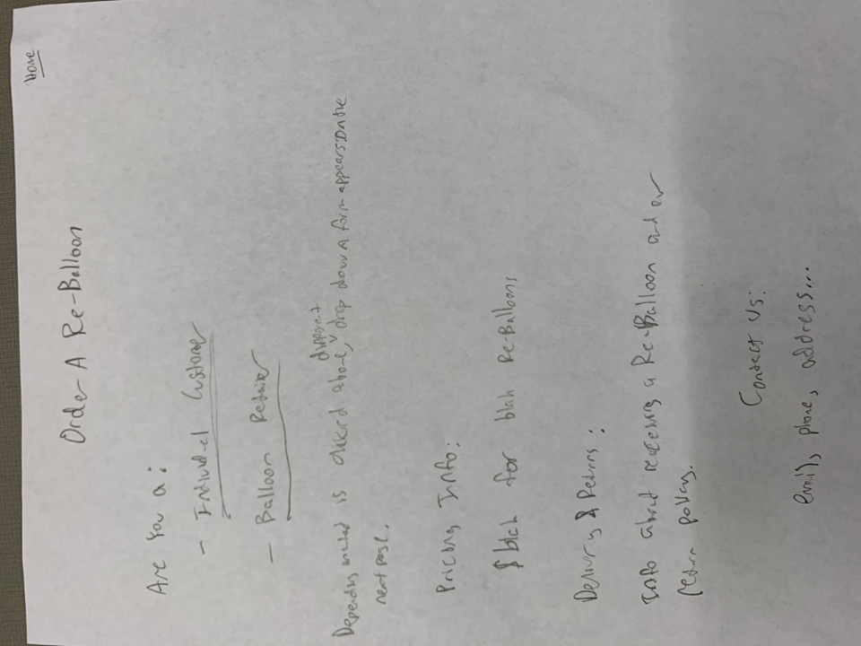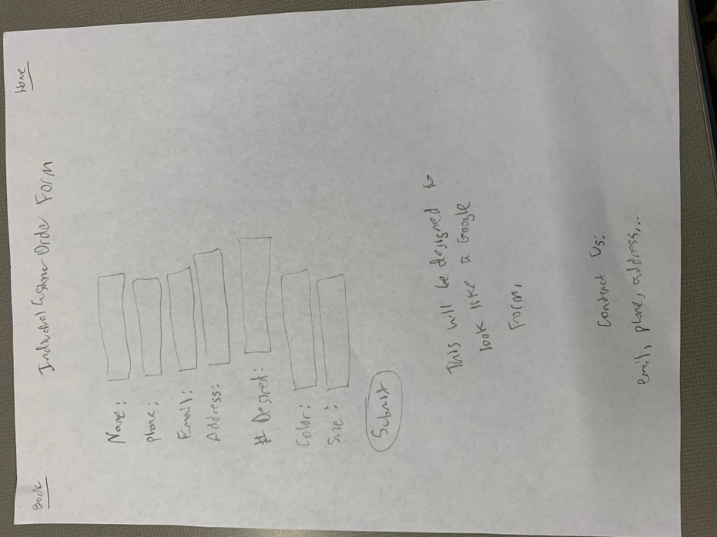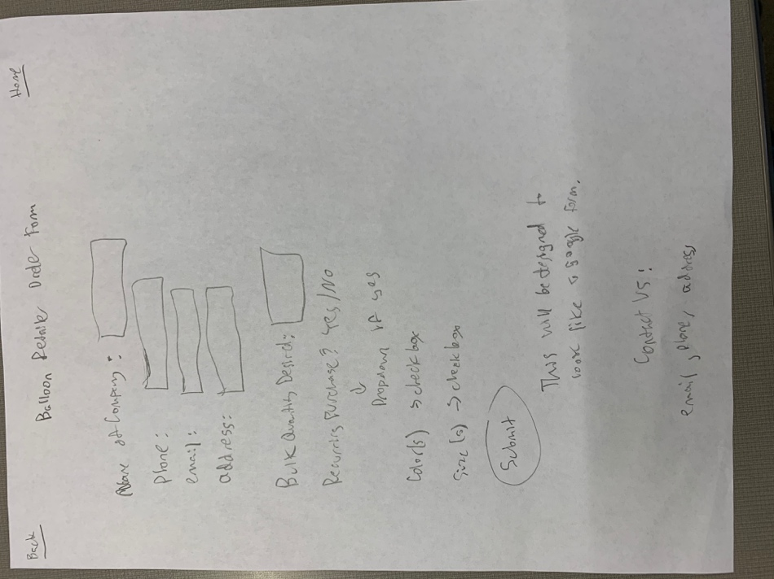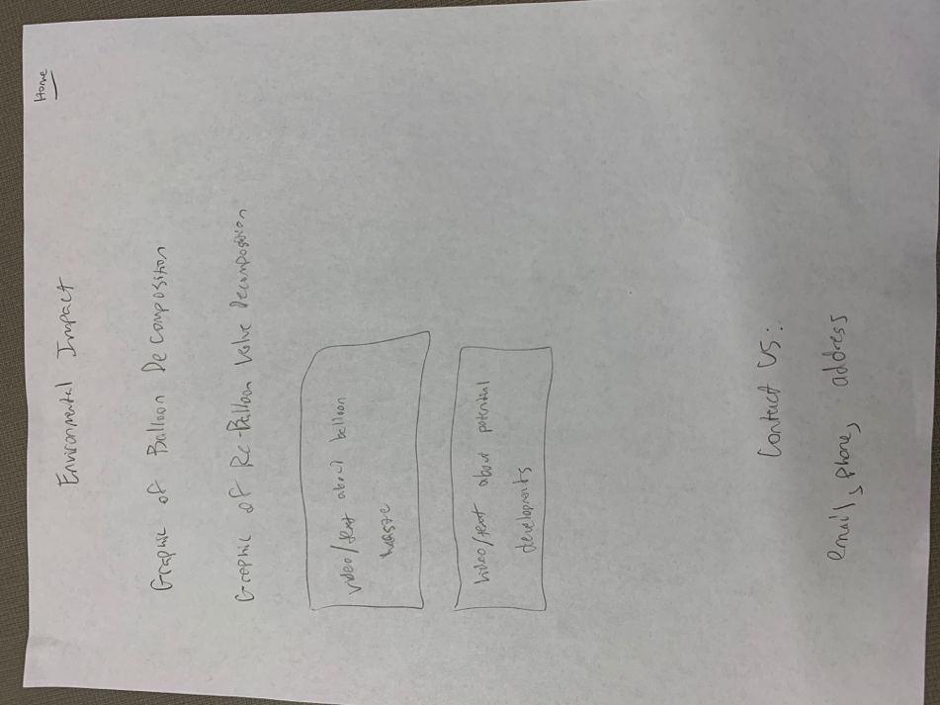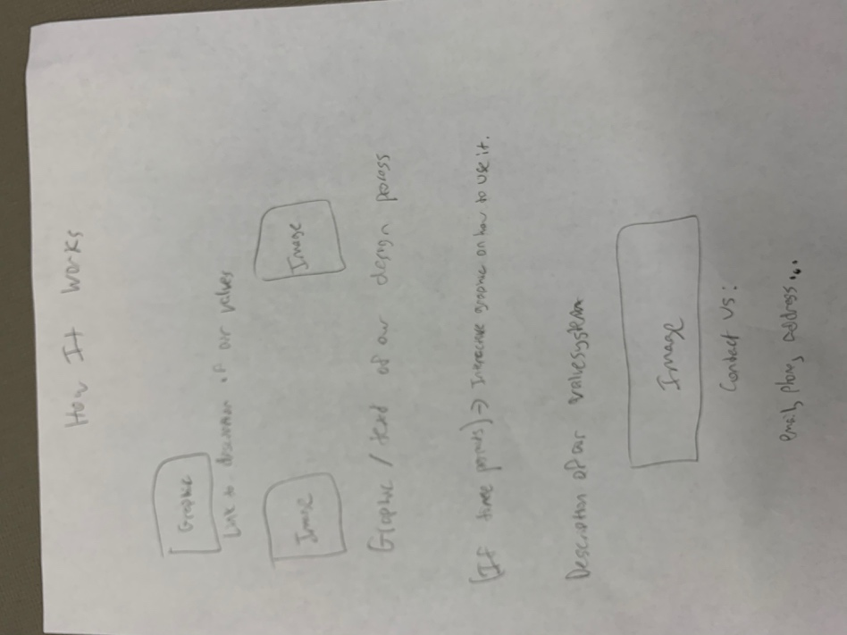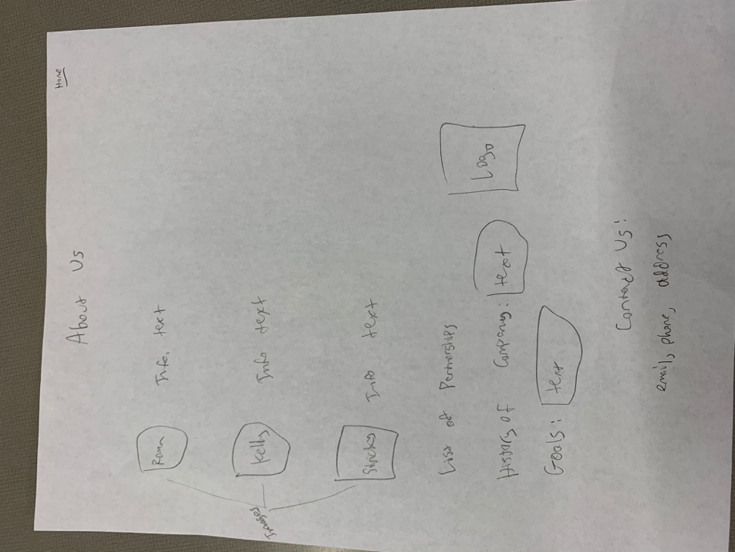

Design Testing Results:

Tester 1: My dad
- Understood the layout of the site well
- Stated that I would likely need much more about us as a company
- Was worried about having the ordering system function properly

Tester 2: Will Hegstrom
- Didn’t think the back button was necessary
- Also thought we needed more information

Tester 3: Yos Wagenmans
- Also wanted more information about us as a company
- Liked the organization of the important aspects of Re-Balloon with different pages
- Thought that the ordering form was too complicated to be always displayed

I got rid of the back button which was going to be on every page – the regular internet back button works fine – and added a section for “About Us.” I also simplified the ordering form by making it a dropdown with only certain sections showing based on whether the customer/site user is an individual or a balloon company.

Prioritization of Features:

Definitely will Implement: Logo and Title, Links below this routing to “About Us,” “Environmental Impact,” “How it works,” “Order a Re-Balloon,”. Slogan and quick facts in middle of page. At bottom of page, contact info for our company. Each page from the links will have text into and pictures. Environmental Impact will have graphs and comparison tables. How it works will have pictures to show a walkthrough of usage. Order a Re-Balloon will have a simple form where they request to order either as an individual or balloon store. This will send information via POST to create one of two forms – one for the individual and one for the balloon store. This will put their information into a database.

Will Implement If I have time: Really clean automatic scroll down on the main page, or changing backgrounds for each page. A sign up for email list form that will result in literally sending the user mails. There will be certainly more that falls into this category, as I continue to figure out what I want our website to have with Kelly and Stricky.

Database Design:

For now, I can think of two tables: one for the order form and one for the email list. It is definitely possible that more necessary tables will emerge as my company continues to develop. The order form will contain columns related to name, purpose of ordering, quantity, color, date needed by, and maybe where they heard about Re-Balloon – it would also need payment info but that is not something that will actually be used while this website is through the CS server. The email list form would ask for contact information and would contain that within the columns to autofill aspects of forming an email to be sent automatically.

Proposed Implementation Schedule:

All pages with no CSS, with navigation to the home page from each -
End of this week.

Logo and Title formatted properly in main page, Information and facts displayed clearly in main page, contact info at bottom of every page – End of week of the fourth

Images and info inserted properly in each page, selection of form choice for the order page complete – end of week of the 11th

Order form complete, database tables constructed, functions properly – end of week of 18th

CSS complete for main page at the least (should be fast to do other pages, they will be similarly styled).

Add any features I can that I currently have as “if I have time,” and others that will probably come up as I work with Kelly and Stricky on the company itself, finish CSS for all pages – end of week of the 25th. This does interfere with Thanksgiving break so I hopefully will have some of this done already.

Fix all apparent bugs, clean up CSS if necessary – end of week of 2nd (which is the 6th, the final due date!).

Potential showstoppers and Open Questions:

Questions (more will probably arise):
- Should I have the contact and order tables interact with each other? Will that be necessary?
- How simplistic do I want the website to be? How much information should be provided on each page?
- What way do I want users to navigate? Will things appear as buttons or links? Will there be auto scrolling?

Showstoppers:
- Not being able to navigate between pages efficiently and correctly
- The order form not functioning correctly
- If it’s not visually appealing, the website will be pretty useless – CSS needs to be good!
- Again, more will probably arise as I determine what more the website needs in correspondence to my company progressing.

