Leo Schuehle
Ms. O’Neil
Computer Science IV
29 October 2019
Design Document
FUNCTIONAL OVERVIEW:
My project will ask users what types of movies that they like, their favorite movie of all time, and then it will recommend movies that the user can add to their list. The list will then be viewable by logging in to an account, which will be saved into a database. The targeted audience is movie fans.

DESIGN OVERVIEW:
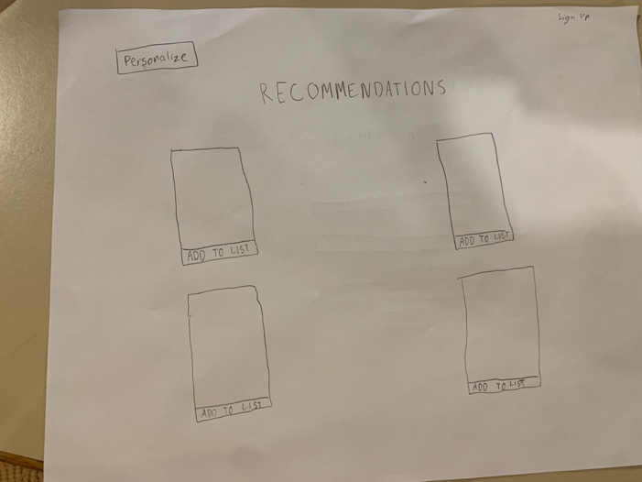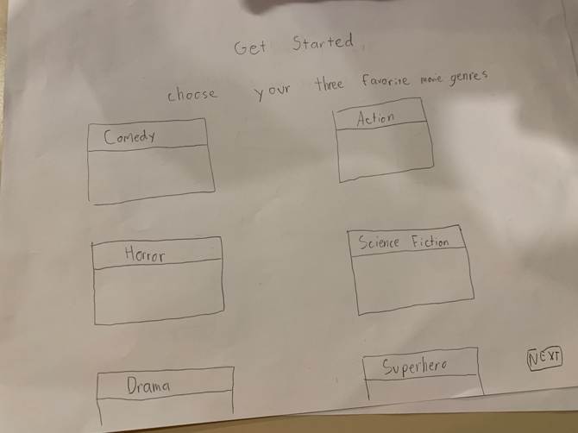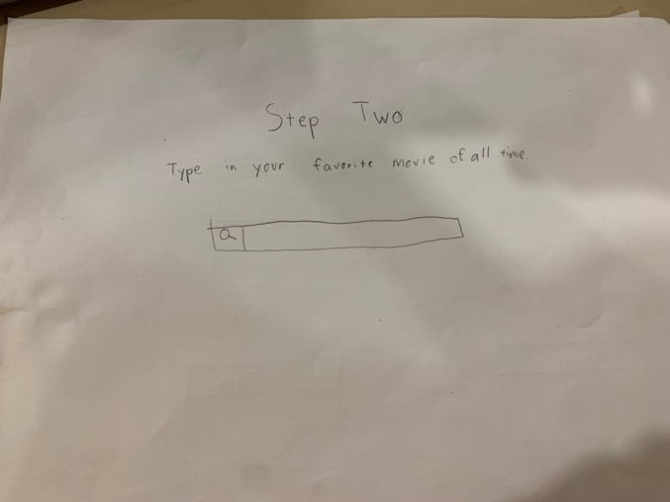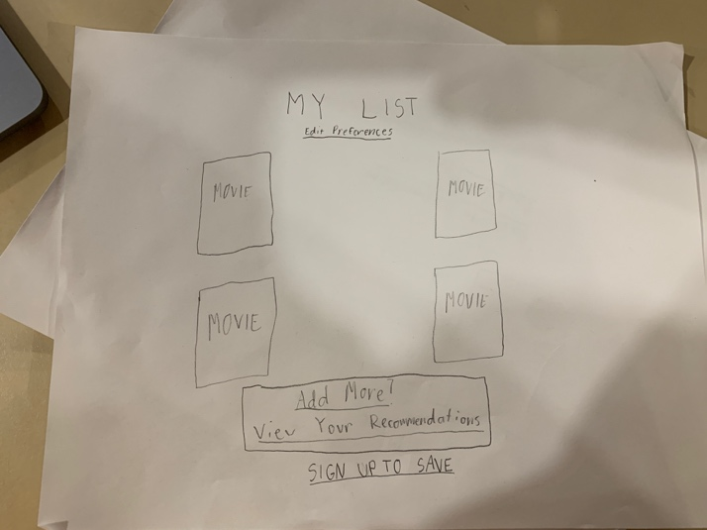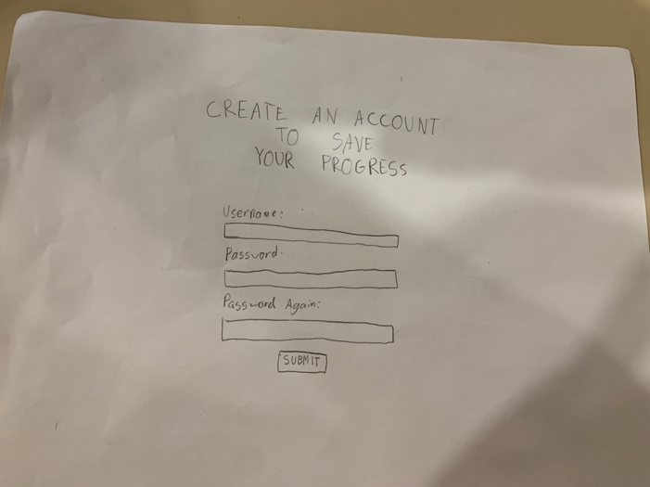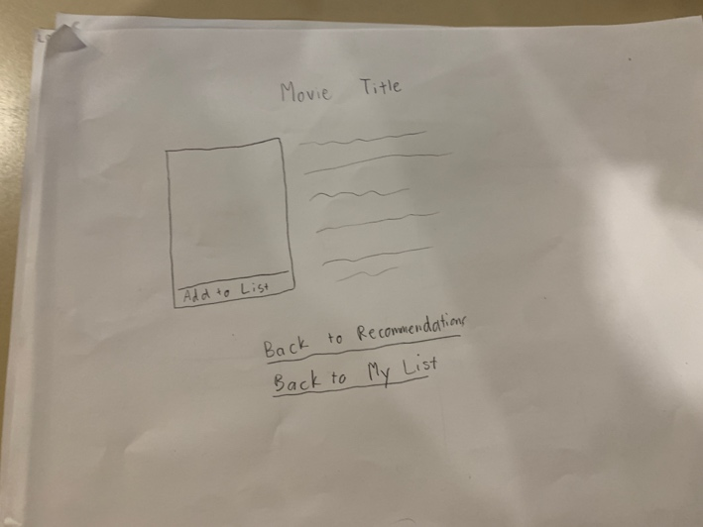

DESIGN TESTING RESULTS:
Tested by Alex Baker & Ryan Tjoa
- Added the ability to go back and change the chosen genres by the user.
- Made it more clear which buttons are which.
- Changed the frontpage to be the recommendation page which initially just shows popular movies but then changes as the user personalizes their account.
PRIORITIZATION OF FEATURES:
Definitely will implement: The adding of movies to a list for each user. An account system. Import some sort of movie database. Perhaps IMDb if it’s available.
If I have time: I want to be able to indicate if movies are available on Netflix, Prime Video, Hulu, etc. I also would like to include images for each movie. I don’t exactly know how APIs work, but I think that this might be able to just happen if I use an existing movie database with that information stored in it.
DATABASE:
I expect to only use this database, but there may be more as I progress with the project.
Id | Username | Password | Favorite movie | Favorite genre 1 | Favorite genre 2 | Favorite genre 3

IMPLEMENTATION SCHEDULE:
11/3 – Research and begin understanding how to use a database/API.
11/5 – Have a mildly functioning homepage/getting started page.
11/8 – Create a very, very simple recommendation algorithm.
11/10 – Begin implementing a database/API from IMDb or a similar service.
11/12 – Have all of the pages done in the form of a basic template of some sort.
11/16 – Have my desired database integration completely implemented.
11/19 – Start implementing an account feature.
11/22 – Start working/make significant progress with CSS.
11/26 – Have the website completely functional, with only a few bugs and some additional work to do with CSS.
12/6 – Have any and all bugs worked out. Make the CSS look the best I can.

POTENTIAL SHOWSTOPPERS:
- Integrating a database has the potential to be very difficult but is also basically essential to getting my project done unless I drastically scale down the scope.
- CSS has consistently been very challenging for me, so getting a website that not only functions but looks good while doing so is going to be difficult. I will focus on getting a working website first.
- Making the website user-friendly at all.
OPEN QUESTIONS:
- What exactly is an API and how would one be implemented to benefit my project and where would I find it and how do I use it?
- How realistic is this idea to actually get done?

