Aditya Pall-Pareek’s Website Design Document
Functional Overview:

This will be a gray market auction website for a fake university. The idea is that it will be a place where people can auction off their spots in elective classes to other people. The user will be able to sign up for an account and then either post auctions or click on classes to see if anyone is holding an auction for them. The auctions will not have an expiration time or anything, it will just end when the person who put the class up for auction is satisfied.

Design Overview:
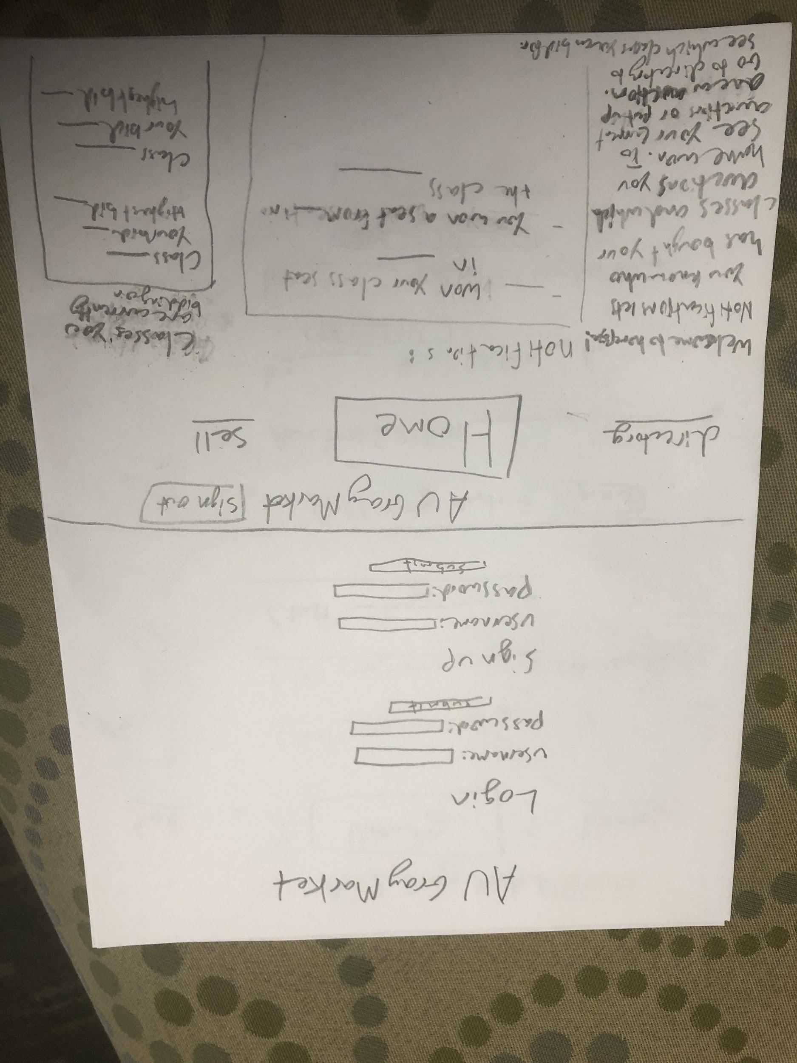
These are the main two screens. After logging in or signing up you go to the Home page, from there you can see your notifications, current auctions, and info page.
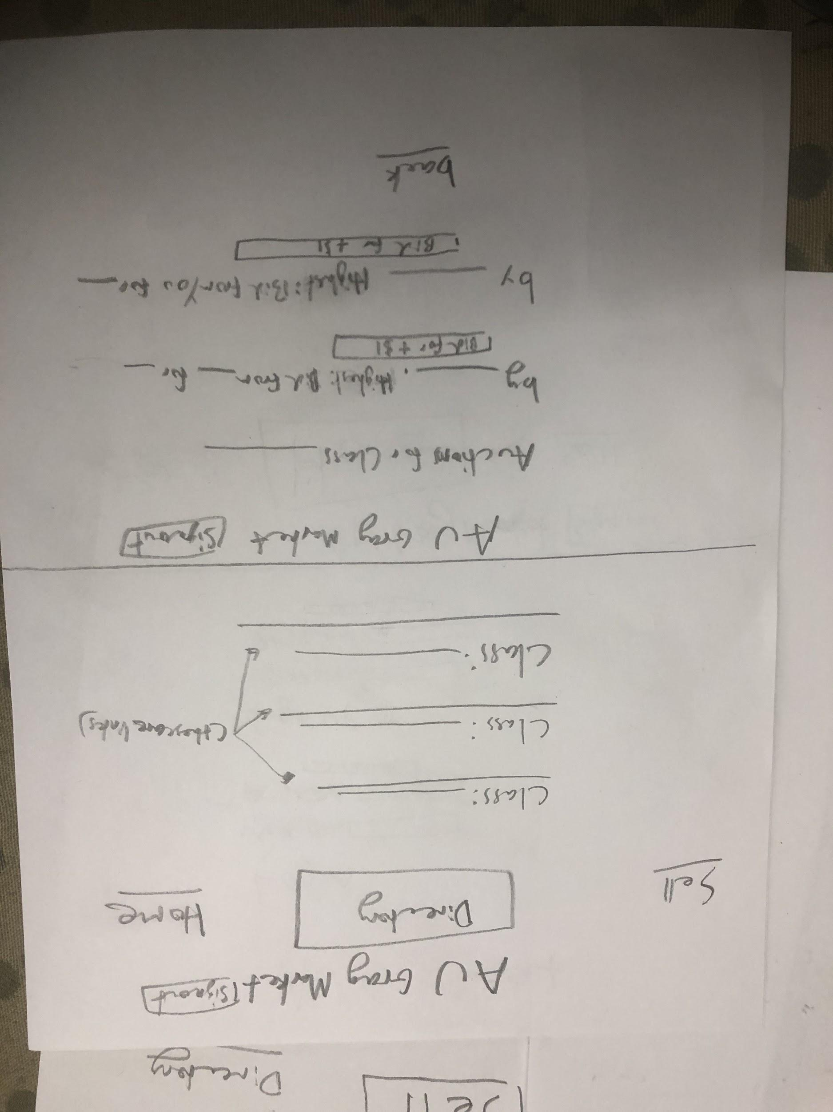
This is the directory page, from here you can click on a class you want to bid on and see all the auctions that are going on for that class. There you can bid on different class seats and see if you are the lead bidder.
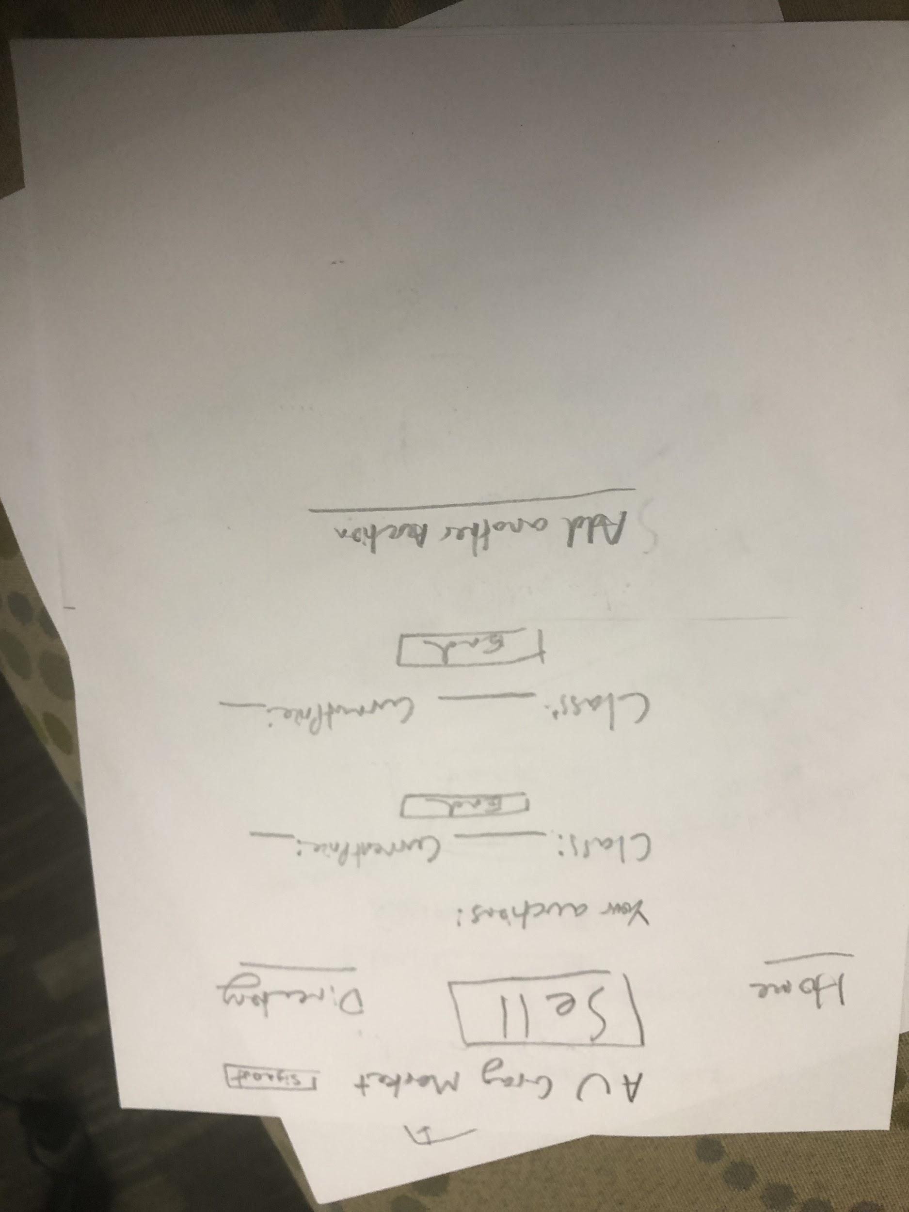
This is the sell page, from here you can see how your current auctions are going and also add another auction. Clicking on add another auction takes you to the next page.
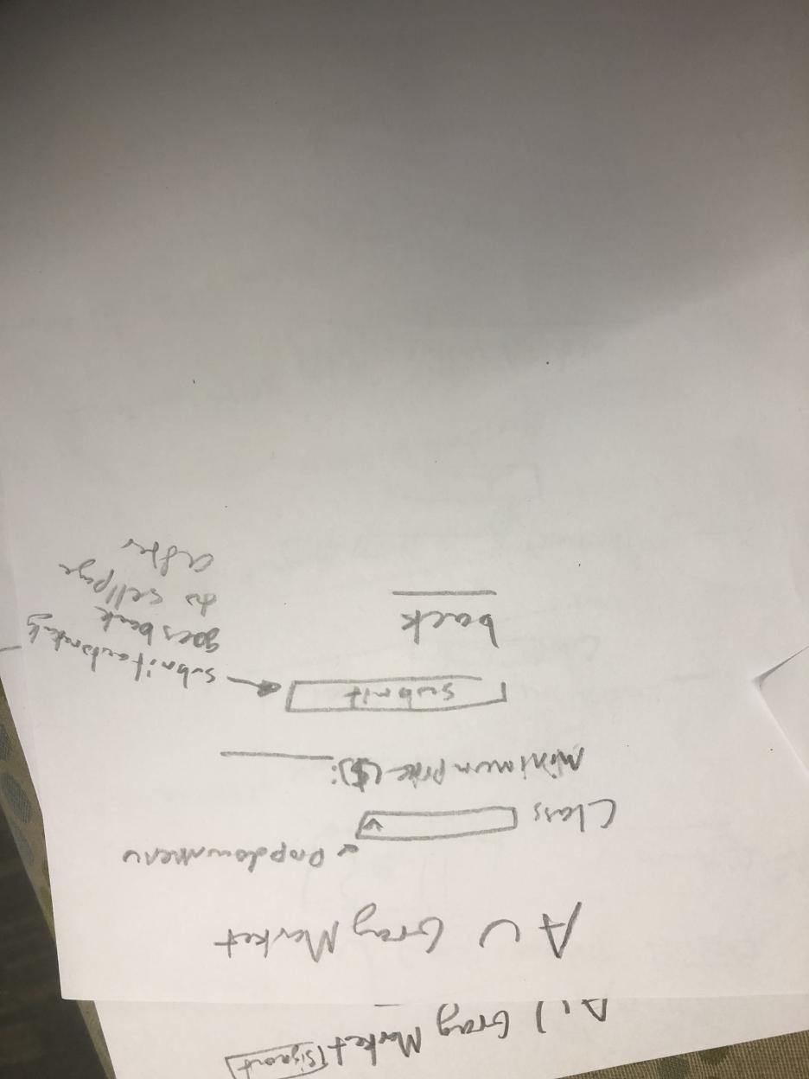
Here is the page you go to when you want to create a new auction. You can choose your class and minimum price and then either submit it or go back if you don’t actually want to make another auction

Two Changes I made from Testing Design:
- From testing with Ryan Tjoa
  - Added more information on the home page like on other buying websites, I decided to put the auctions that the user is currently bidding on so they can see it easily on the home page. If in testing users still think it can use more information I can reformat it to add more
- From Testing with Bobby Eleveld
  - Gave some more information on the home page to explain what all the links are and how to get to the selling and buying places

Prioritization of features:
Definitely will implement:
- Account system, log in, sign up, things specific to different people’s account
- A directory of the electives that can be sold or bought
- An auction system where people can post class seats and bid for them
- An inbox system where people can see if they won the auction or who won their auction. It will tell them the price they agreed upon. (It won’t actually facilitate the transaction on the website)

Will implement if there is time:
- A quick buy system where you can just buy a seat in a class for a set price
- A comment section where people can say if a transaction was actually fulfilled or if the buyer/seller is reliable
- An info page about each class where people can also submit comments on different classes or teachers

Database design:
- Username/Password
  - Id
  - Username
  - Password
- Auctions
  - Id
  - Id of class being auctioned
  - Auctioneer’s id
  - Leading Bidder’s id
  - Boolean saying if it is open or closed
- Bids
  - Id
  - Bidder’s id
  - Bid value
- Classes
  - Id
  - Class name

Proposed implementation schedule:
- November 7th sign up/log in/account working without css
- November 14th auction databases set up, can be tested
- November 20th UI implemented
- November 23rd 1st draft CSS done, keep testing and iterating until testing day
- November 27th Testing day
- December 6th Project due
- December 9th presentation due

Potential showstoppers and questions:
- Making the Auctions update in real time as the values in the database change might be a potential showstopper because it would mean you would have to constantly refresh

