Tanvi Ganapathy
Section B
Website Design Document
10/28/19
Appointment Scheduler
Functional Overview:
This website allows users to have a list of upcoming meetings that have been scheduled through the site. These meetings can be private (with themselves) or public (with one or more other users of the website). Users will also have a list of times that they are generally available, and this list can be viewed by other users of the site. The list of available times and the list of upcoming meetings can be updated. After searching when another user is available, users can send out meetings requests to them during the given times. Meeting requests can be accepted or declined and accepted meetings will show up in the list of upcoming meetings. Users will be able to view and delete their messages once they have been read. Users will be asked to create an account to access these features.
The intended users of this website are people that want to be able to track their appointments with other users of the website (you can also track private events, but the website is geared towards creating meetings with other users). So, this site will be useful if the people that you have appointments with also have accounts. This site is intended for communities (such as a school) where all members can have an account and it is possible to request a meeting with anyone in the community (for example, teachers can schedule meetings with students and students can schedule study sessions with other students).
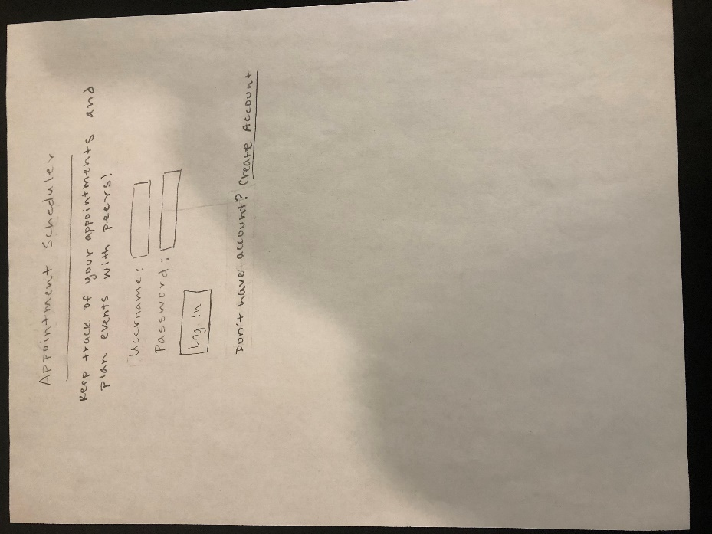
Design Overview:
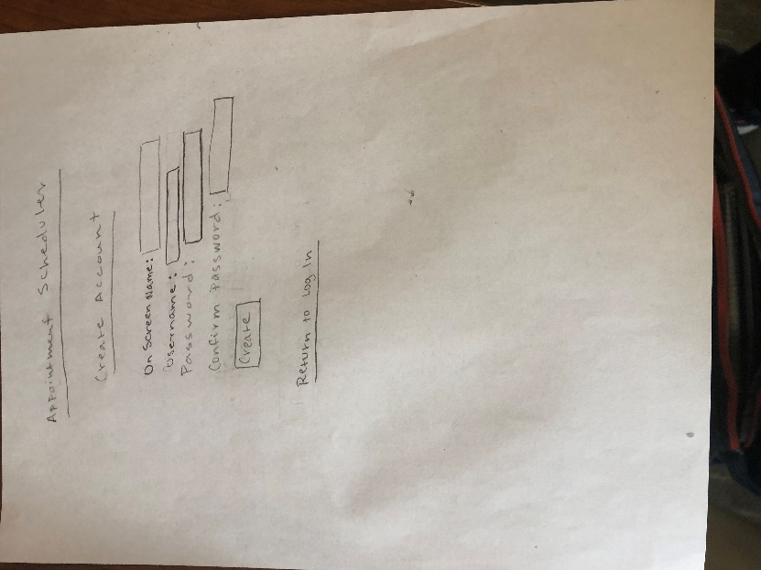
Below: opening screen (log in) and create account:
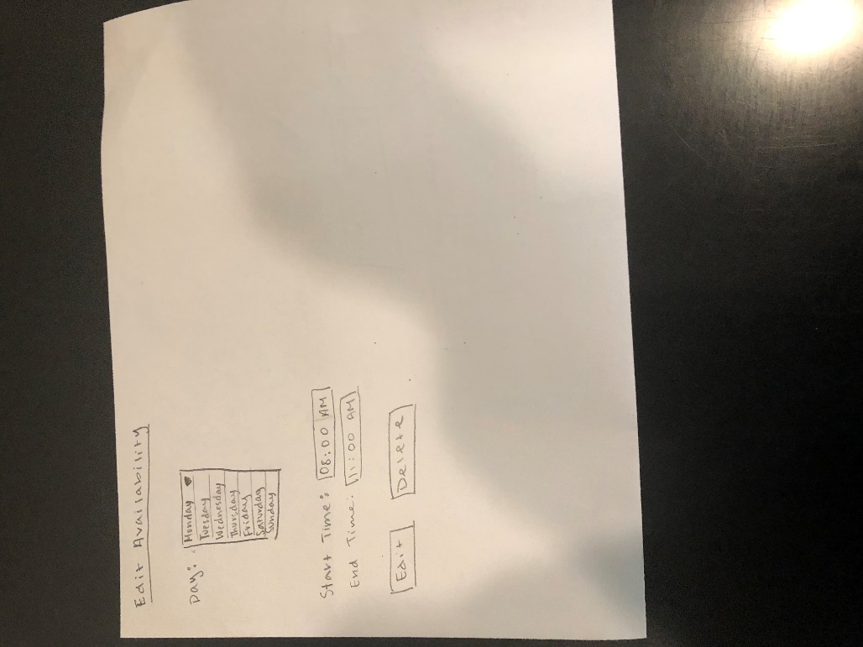
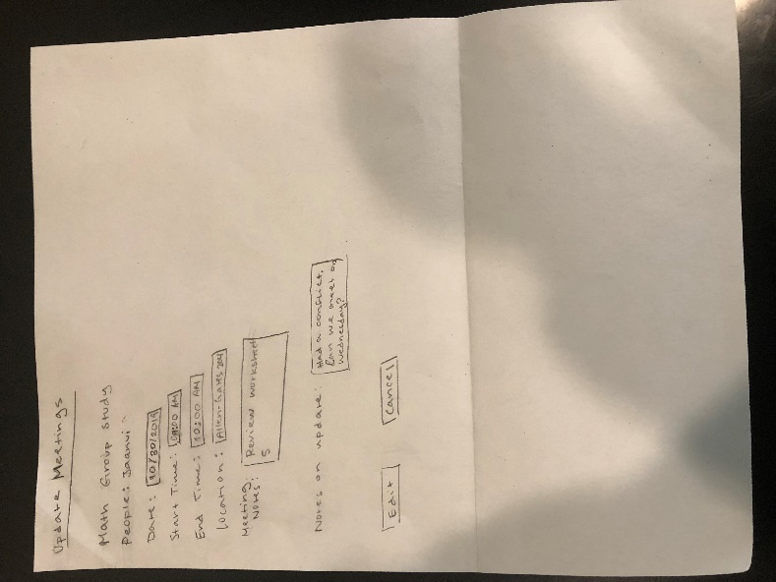
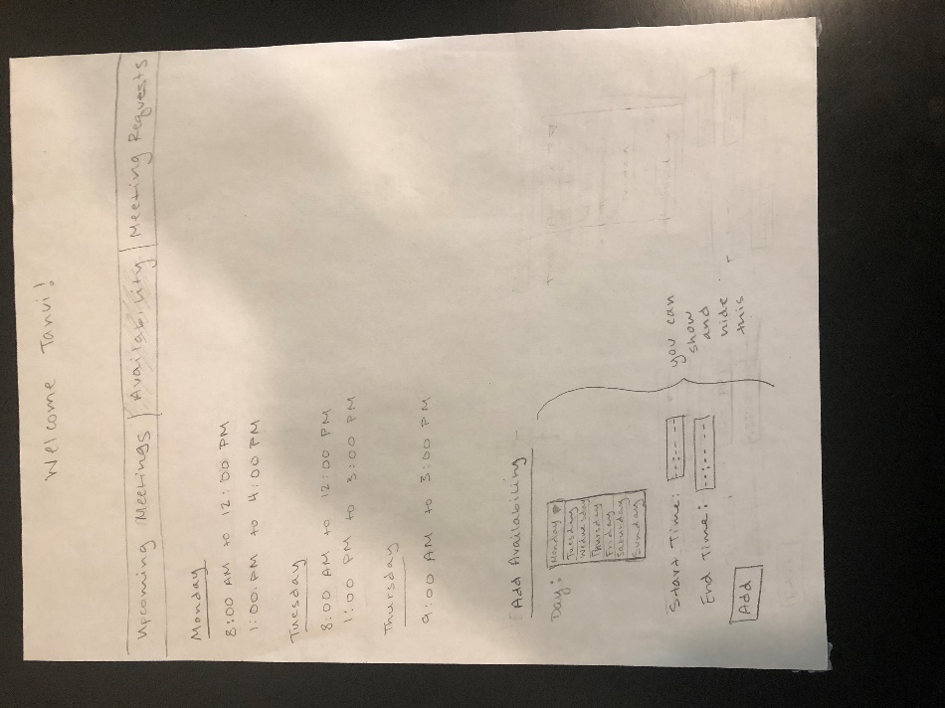
Above: availability page and clicking on a time redirects to edit availability page
Below: opening page (upcoming meetings) and clicking on a meeting redirects to update meetings page

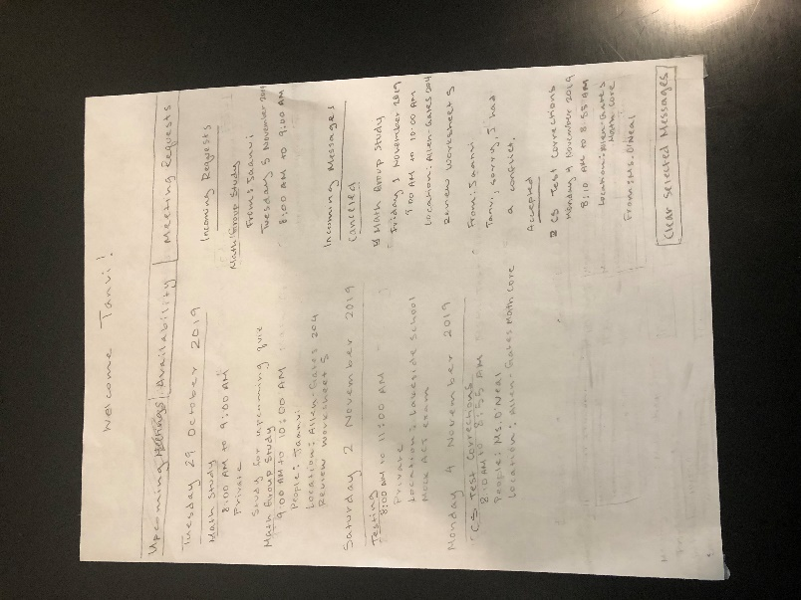
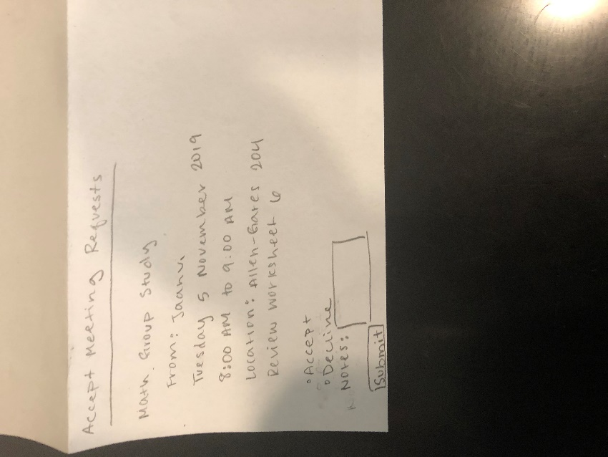
Below: (left) when you click on an incoming meeting request, it redirects to accept meeting requests page. (right) meeting requests page where you can search availability and send a new meeting request (available times will show up on this page exactly as they would on the availability page (indicated by …, there might be more available times for other days of the week)):
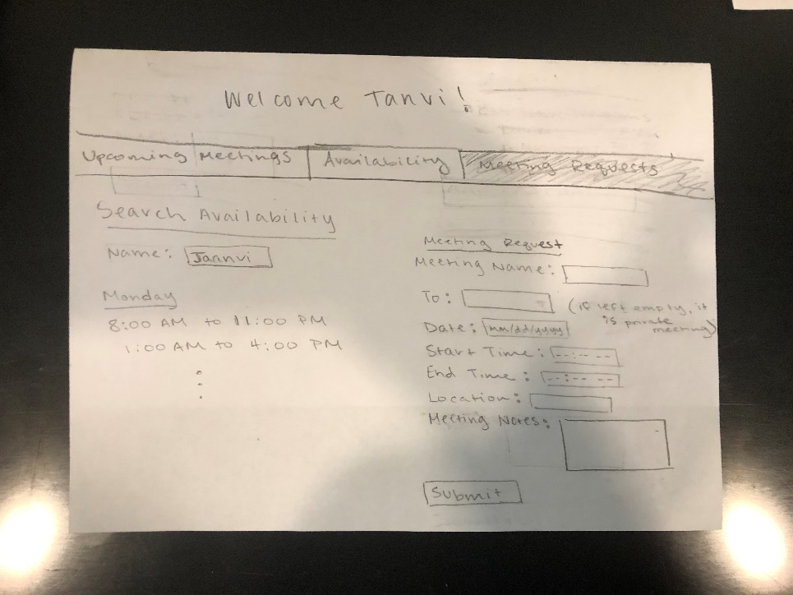
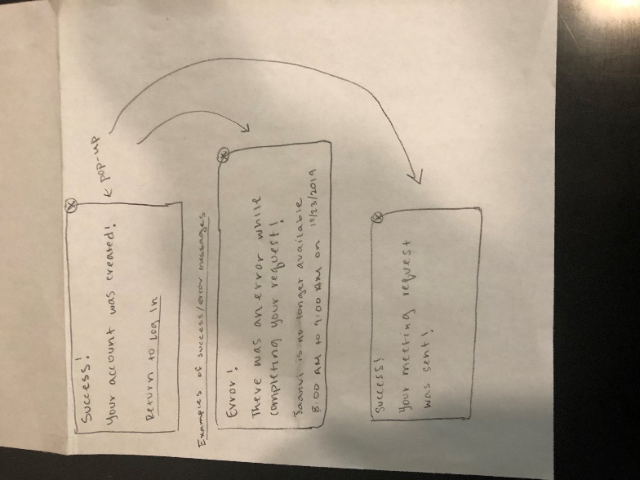
Below: pop-ups that appear when the user performs an action and informs of whether it was successful or not:

Design Testing Results:
I tested with Vidisha, Liz, and my mom. When I tested with Vidisha, she recommended having to click on an upcoming event that redirects you to the form to edit or cancel the event instead of having these forms at the bottom of the page. I decided to also extend this to the availability editing features. If the user wants to change their availability to be 5-6 instead of 4-5, they would click on the current availability time they have which leads them to a form. When talking to Liz, she recommended that if I include the add availability form on the availability page, it should be able to show and hide, so it doesn’t distract from the other information. When I talked to my mom, she said that I should move incoming requests and messages to the upcoming meetings tab. I liked this idea because then all the changes to your schedule are in one place, and you can view messages and requests while also looking at your upcoming meetings. Moreover, when I tested, I felt that it was slightly confusing when people created an account and they didn’t know if it would automatically return them to the log in page, or they had to do it themselves. To reduce this confusion, I added a link back to the log in page from the pop-up that tells the user that their account was created successfully. This is in addition to the “return to log in” link that was already on the page.
Prioritization of Features:
Definitely Will Implement:
Users can create an account and log in to their account
Users can update a list of times that they are available (that is public to all other users)
Users can search up the availability of other users (plan to implement in a way that each user must have a unique on-screen name)
Users can send out meeting requests to other users (and themselves) that can be accepted or declined (users won’t have to accept meeting requests sent to themselves, it is automatically added to the calendar (private meetings also allow the user to make time in their calendar to meet with someone who is not also a user of the site))
Accepted requests make up a list of upcoming meetings
Whether meeting was accepted or declined, a message is sent back to the user who sent the request
Users can cancel upcoming meetings (which sends a message to all other users involved)
Users can edit the time/location/notes of upcoming meetings, and the site will send a new meeting request to all other users involved
Users can view messages and delete them once they have been read (messages are sent when meetings are canceled or edited, and when meeting requests are accepted or declined)
Pop-ups appear whenever the user performs an action (cancel meeting, send meeting request, sign up for an account, etc.) that informs the user of whether the action was successful or not, an error message is displayed if the action was unsuccessful
Will Implement If I Have Time:
Improve the search for other user’s available times so multiple users can have the same on-screen name
Users can create groups (of other users) within the site, and they can select a group as the recipient of a meeting request which sends the request out to all users in the group and the meeting can’t happen unless they all accept
Invite new people to a meeting through the edit meeting feature
Users can color code their appointments based on subject of the meeting or the people they are meeting with
Users can post messages on their availability calendar to inform other users of irregularities in their schedule
Display available times and upcoming meetings in a calendar format with different views (daily, weekly, etc.)
Features to maintain an account forgot password, change password, change on screen name, etc.
Messages and meeting requests are sent and appear in real-time, without the user having to refresh.
Can send blank meeting requests (don’t have to have a proposed date and time) to a group (for example, it is useful if every student in a class has to meet with the teacher individually about a topic and the students need to remember to propose a time to do this)
Database Design:
Users (track accounts):
Id, on_screen_name, username, password (hashed passwords)
Meetings (track meeting requests and events (but not the recipients)):
Id, sender_user_id, name, date, start_time, end_time, location, notes_about_meeting
UsersMeetings (track the meetings that each user is attending):
Id, user_id, meeting_id, status (pending (recipient hasn’t yet accepted or declined) or accepted)
Availability (track user’s public list of times they are available):
Id, user_id, day, start_time, end_time
Messages (keep track of messages):
Messages are sent when meetings are canceled or edited, and when meeting requests are accepted or declined.
Id, sender_user_id, action (canceled, accepted, etc.), message_content (whatever was typed by the user sending the message)
SentMessages (keep track of sending and receiving messages):
Id, to_user_id, message_id
Implementation Schedule:
11/5/19 – User can create account and login and general website structure is in place
11/8/19 – User can add and edit times that they are available
11/12/19 – Users can search up the availability of other users (also in preparation of sending out meeting request)
11/14/19 – Teacher Check-In (test all existing features)
11/15/19 – User can send out meetings requests that can be accepted or declined and these events show up in upcoming meetings, a message is sent back to the user who made the initial meeting request when the meeting is accepted or declined
11/19/19 – User can cancel events and a message is sent out to other users involved, user can edit the time/location/notes of events and an updated meeting request as well as a message is sent out to other users involved with the edits
11/22/19 – User can delete their messages once they have been read, all pop-ups that communicate the success or failure of an action work
11/26/16 – CSS and testing the program
11/27/19 – Testing Day (be prepared to test website with classmates)
11/4/19 – Test program further (standard and edge cases) and finish CSS, make edits as necessary from testing day
12/6/19 – Web Project Due (all features should be working, and optional features added if there was time)
Potential Showstoppers:
If I don’t figure out how to pass get variables through a link, I will have to restructure the website (this is important in situations where the user clicked on something to edit it and it redirects to another page (meetings, etc.))
If I don’t figure out how to use JavaScript to switch between the tabs, I will have to restructure the website, so I redirect to a new page. I would like to avoid this so I’m not constantly reloading the page for every user request.
I also need to learn how to use JavaScript to show/hide the add availability form. This is also for the structure of the website, so the availability page is clear to the user.
Open Questions:
How do I create a pop-up box? How do I create a pop-up box with links and forms inside it? I want to use a pop-up box whenever a user performs a request (cancel meeting, edit meeting, etc.) to make it clear whether the request was successful or there was an error.
How to link to a URL and pass a GET variable? For editing/canceling meetings and editing availability
How to display the previously chosen value in the input, so user doesn’t have to re-input information? For editing meetings and availability
Optional
How would I have incoming messages and requests appear in real time?

