Henry Evans
Computer Science IV
October 30th, 2019

Design Document
Functional Overview:
Purpose: I want my website to serve as a guide and forum for fisher(wo)men across the state of Washington. I want it to be a center of information for fisher(wo)men to share and learn from each other.

Intended Users: My intended users are fishermen and women in Washington. I want to design my website for repeated users who fish a lot and will use the website multiple times. That being said, I want my website to be simple enough that one-time users can understand the interface and get the fishing information they require.

Design Overview:
See bottom of document for pictures

Design Testing Results:
Test #1: Alex Baker:
I interviewed Alex and he focused on making a post. He said that he liked the front page of the website and encouraged me to use a lot of pictures because he said, “I like to look at pictures.” He was less interested in the idea of the river currents and suggested that we give the necessary information so anyone, regardless of knowledge, can interpret the different readings. One major change that he suggested was having the home button in the left corner (seen in my updated protype) so that it is easy to navigate between pages.

Test # 2: Jon Evans
My dad is an avid fisherman and was very excited about the concept of this website. He said that similar websites with trip logs exist but aren’t commonly used. He was the one that suggested including river currents on a map because it is something that he looks at before going fishing. He also stressed the importance of pictures because he loves to share images with his friends. Originally, I was planning on only having one picture per post, but he suggested up to 5 so that a user can include pictures of fish and the surroundings. He suggested having an additional button so that the user can share it to social media directly from the website.

- Prioritization of Features:
Definitely will implement:
  - Front page with pictures
  - Embedded tweets on front page
  - Ability to write trip reports
  - Anility to view other trip reports
Will implement if I have time:
  - Reports viewed on the map
  - River currents maps that updates automatically
  - Post to social media option after writing a report
Database Design:
Table 1: Table full of reports
Columns: id, first name, last initial, date, rating (int 1-5), location (if time allows. Would be converted into value for longitude and latitude), and up to 5 images)

Table 2: Table full of river conditions
Columns: id, tracker number, name, historical average flow (int), current flow (int), and date/time of last updated (in form of string)

Proposed implementation schedule:
Starting Immediately:
  - Confirm database design
  - Set up basic pages for front page and trip results page
November 12th - End of November:
  - Have main page set up with carousel of images
  - Have the trip reports working. Both viewing others and writing your own
  - Begin to work on search and filters while viewing trip reports
Starting in December (in order of working on):
  - Finish the search and filters for trip reports
  - Work on embedding the tweets on my front page
  - Make the trip reports show up on a map.
  - Continue to refine my trip reports page
  - If time allows:
    - Import river conditions from database
    - Show river conditions by marker location ids
    - Show the different markers on a map
Throughout:
  - Working on CSS as I work. My main goal is to have an aesthetically pleasing website with an easy to use interface, so I want to prioritize this throughout

Potential Showstoppers and Open Questions:
  - Unable to do mapping effectively
  - Difficulty with getting information for river conditions
    - Is there API for this website? How will I constantly be updating the values in the table? Is this even worth it?

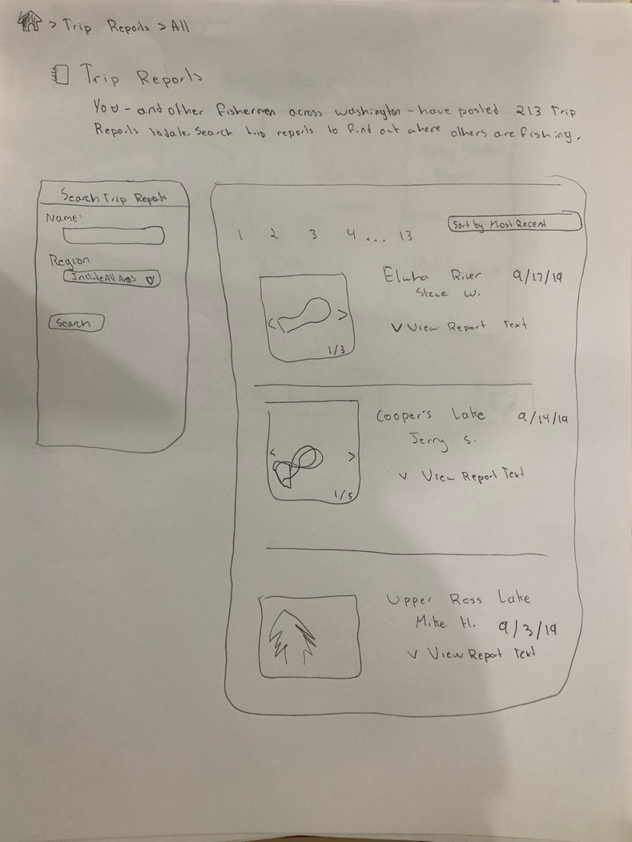
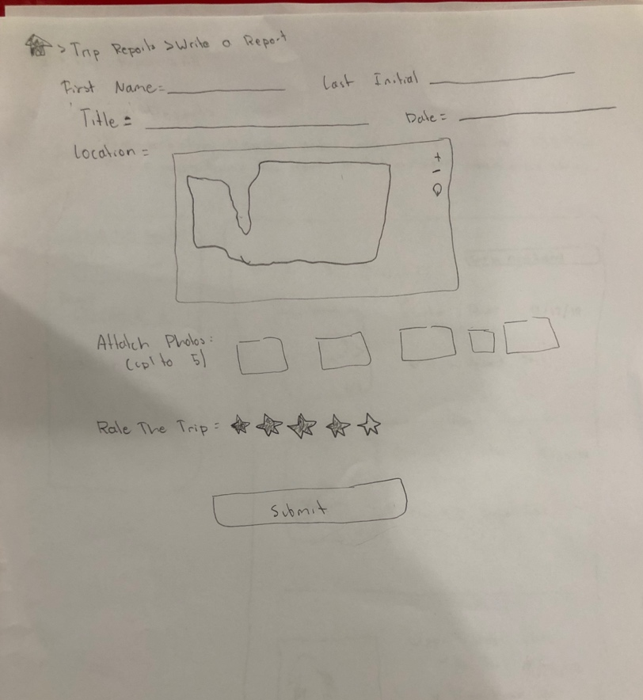
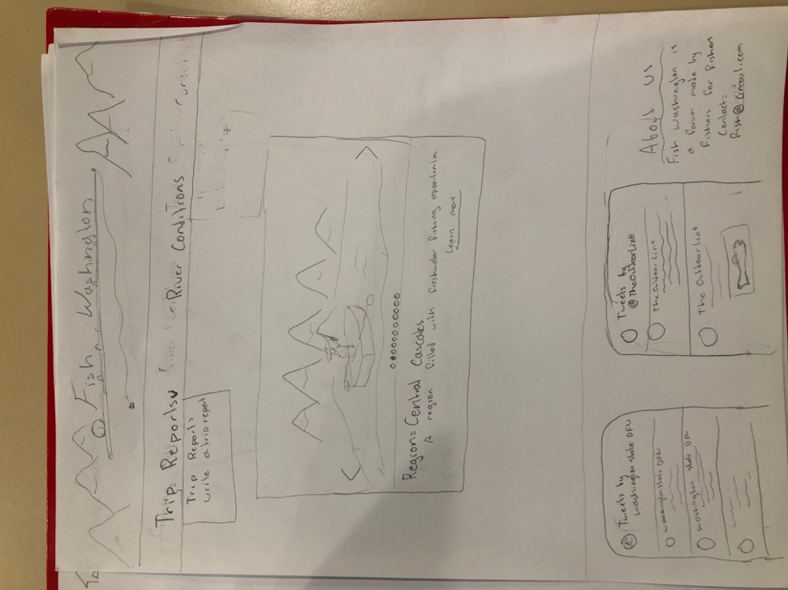
Photos of prototype:

